**LAPORAN PRAKTIKUM**

**BAHASA PEMROGRAMAN 1**

(**DOSEN PENGAMPU : DEDE HUSEN., M.KOM)**

**Modul 4**



DISUSUN OLEH :

NAMA : MOHAMAD ABAN SY’BANA

NIM : 20230810012

KELAS : TINFC-2023-04

**TEKNIK INFORMATIKA**

**FAKULTAS ILMU KOMPUTER**

**UNIVERSITAS KUNINGAN**

**2024**

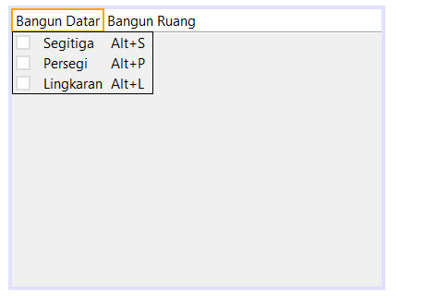

/*

* To change this license header, choose License Headers in Project Properties.

* To change this template file, choose Tools | Templates

* and open the template in the editor.

*/

/**

*

* @author Suci Indah Lestari

*/

public class bangun extends javax.swing.JFrame {

/**

* Creates new form bangun

*/

public bangun() {

initComponents();

}

/**

* This method is called from within the constructor to initialize the form.

* WARNING: Do NOT modify this code. The content of this method is always

* regenerated by the Form Editor.

*/

@SuppressWarnings("unchecked")

// <editor-fold defaultstate="collapsed" desc="Generated Code">

private void initComponents() {

jMenuBar1 = new javax.swing.JMenuBar();

jMenu1 = new javax.swing.JMenu();

jMenuItem1 = new javax.swing.JMenuItem();

jMenuItem2 = new javax.swing.JMenuItem();

jMenuItem3 = new javax.swing.JMenuItem();

jMenu2 = new javax.swing.JMenu();

jMenuItem4 = new javax.swing.JMenuItem();

jMenuItem5 = new javax.swing.JMenuItem();

jMenuItem6 = new javax.swing.JMenuItem();

setDefaultCloseOperation(javax.swing.WindowConstants.EXIT_ON_CLOSE);

jMenu1.setText("Bangun Datar");

jMenuItem1.setAccelerator(javax.swing.KeyStroke.getKeyStroke(java.awt.event.KeyEvent.VK_S, java.awt.event.InputEvent.ALT_MASK));

jMenuItem1.setText("Segitiga");

jMenuItem1.addActionListener(new java.awt.event.ActionListener() {

public void actionPerformed(java.awt.event.ActionEvent evt) {

jMenuItem1ActionPerformed(evt);

}

});

jMenu1.add(jMenuItem1);

jMenuItem2.setAccelerator(javax.swing.KeyStroke.getKeyStroke(java.awt.event.KeyEvent.VK_P, java.awt.event.InputEvent.ALT_MASK));

jMenuItem2.setText("Persegi");

jMenuItem2.addMouseListener(new java.awt.event.MouseAdapter() {

public void mouseClicked(java.awt.event.MouseEvent evt) {

jMenuItem2MouseClicked(evt);

}

});

jMenuItem2.addActionListener(new java.awt.event.ActionListener() {

public void actionPerformed(java.awt.event.ActionEvent evt) {

jMenuItem2ActionPerformed(evt);

}

});

jMenu1.add(jMenuItem2);

jMenuItem3.setAccelerator(javax.swing.KeyStroke.getKeyStroke(java.awt.event.KeyEvent.VK_L, java.awt.event.InputEvent.ALT_MASK));

jMenuItem3.setText("Lingkaran");

jMenuItem3.addMouseListener(new java.awt.event.MouseAdapter() {

public void mouseClicked(java.awt.event.MouseEvent evt) {

jMenuItem3MouseClicked(evt);

}

});

jMenuItem3.addActionListener(new java.awt.event.ActionListener() {

public void actionPerformed(java.awt.event.ActionEvent evt) {

jMenuItem3ActionPerformed(evt);

}

});

jMenu1.add(jMenuItem3);

jMenuBar1.add(jMenu1);

jMenu2.setText("Bangun Ruang");

jMenuItem4.setAccelerator(javax.swing.KeyStroke.getKeyStroke(java.awt.event.KeyEvent.VK_K, java.awt.event.InputEvent.ALT_MASK));

jMenuItem4.setText("Kubus");

jMenuItem4.addMouseListener(new java.awt.event.MouseAdapter() {

public void mouseClicked(java.awt.event.MouseEvent evt) {

jMenuItem4MouseClicked(evt);

}

});

jMenuItem4.addActionListener(new java.awt.event.ActionListener() {

public void actionPerformed(java.awt.event.ActionEvent evt) {

jMenuItem4ActionPerformed(evt);

}

});

jMenu2.add(jMenuItem4);

jMenuItem5.setAccelerator(javax.swing.KeyStroke.getKeyStroke(java.awt.event.KeyEvent.VK_B, java.awt.event.InputEvent.ALT_MASK));

jMenuItem5.setText("Balok");

jMenuItem5.addMouseListener(new java.awt.event.MouseAdapter() {

public void mouseClicked(java.awt.event.MouseEvent evt) {

jMenuItem5MouseClicked(evt);

}

public void mouseEntered(java.awt.event.MouseEvent evt) {

jMenuItem5MouseEntered(evt);

}

});

jMenuItem5.addActionListener(new java.awt.event.ActionListener() {

public void actionPerformed(java.awt.event.ActionEvent evt) {

jMenuItem5ActionPerformed(evt);

}

});

jMenu2.add(jMenuItem5);

jMenuItem6.setAccelerator(javax.swing.KeyStroke.getKeyStroke(java.awt.event.KeyEvent.VK_T, java.awt.event.InputEvent.ALT_MASK));

jMenuItem6.setText("Tabung");

jMenuItem6.addMouseListener(new java.awt.event.MouseAdapter() {

public void mouseClicked(java.awt.event.MouseEvent evt) {

jMenuItem6MouseClicked(evt);

}

});

jMenuItem6.addActionListener(new java.awt.event.ActionListener() {

public void actionPerformed(java.awt.event.ActionEvent evt) {

jMenuItem6ActionPerformed(evt);

}

});

jMenu2.add(jMenuItem6);

jMenuBar1.add(jMenu2);

setJMenuBar(jMenuBar1);

javax.swing.GroupLayout layout = new javax.swing.GroupLayout(getContentPane());

getContentPane().setLayout(layout);

layout.setHorizontalGroup(

layout.createParallelGroup(javax.swing.GroupLayout.Alignment.LEADING)

.addGap(0, 400, Short.MAX_VALUE)

);

layout.setVerticalGroup(

layout.createParallelGroup(javax.swing.GroupLayout.Alignment.LEADING)

.addGap(0, 274, Short.MAX_VALUE)

);

pack();

}// </editor-fold>

private void jMenuItem1ActionPerformed(java.awt.event.ActionEvent evt) {

// TODO add your handling code here:

segitiga sg = new segitiga();

sg.setVisible(true);

}

private void jMenuItem2MouseClicked(java.awt.event.MouseEvent evt) {

// TODO add your handling code here:

}

private void jMenuItem3MouseClicked(java.awt.event.MouseEvent evt) {

// TODO add your handling code here:

}

private void jMenuItem4MouseClicked(java.awt.event.MouseEvent evt) {

// TODO add your handling code here:

}

private void jMenuItem5MouseEntered(java.awt.event.MouseEvent evt) {

// TODO add your handling code here:

}

private void jMenuItem5MouseClicked(java.awt.event.MouseEvent evt) {

// TODO add your handling code here:

}

private void jMenuItem6MouseClicked(java.awt.event.MouseEvent evt) {

// TODO add your handling code here:

}

private void jMenuItem2ActionPerformed(java.awt.event.ActionEvent evt) {

// TODO add your handling code here:

persegi psg = new persegi();

psg.setVisible(true);

}

private void jMenuItem3ActionPerformed(java.awt.event.ActionEvent evt) {

// TODO add your handling code here:

lingkaran lkg = new lingkaran();

lkg.setVisible(true);

}

private void jMenuItem4ActionPerformed(java.awt.event.ActionEvent evt) {

// TODO add your handling code here:

kubus kb = new kubus();

kb.setVisible(true);

}

private void jMenuItem5ActionPerformed(java.awt.event.ActionEvent evt) {

// TODO add your handling code here:

balok bk = new balok();

bk.setVisible(true);

}

private void jMenuItem6ActionPerformed(java.awt.event.ActionEvent evt) {

// TODO add your handling code here:

tabung tb = new tabung();

tb.setVisible(true);

}

/**

* @param args the command line arguments

*/

public static void main(String args[]) {

/* Set the Nimbus look and feel */

//<editor-fold defaultstate="collapsed" desc=" Look and feel setting code (optional) ">

/* If Nimbus (introduced in Java SE 6) is not available, stay with the default look and feel.

* For details see http://download.oracle.com/javase/tutorial/uiswing/lookandfeel/plaf.html

*/

try {

for (javax.swing.UIManager.LookAndFeelInfo info : javax.swing.UIManager.getInstalledLookAndFeels()) {

if ("Nimbus".equals(info.getName())) {

javax.swing.UIManager.setLookAndFeel(info.getClassName());

break;

}

}

} catch (ClassNotFoundException ex) {

java.util.logging.Logger.getLogger(bangun.class.getName()).log(java.util.logging.Level.SEVERE, null, ex);

} catch (InstantiationException ex) {

java.util.logging.Logger.getLogger(bangun.class.getName()).log(java.util.logging.Level.SEVERE, null, ex);

} catch (IllegalAccessException ex) {

java.util.logging.Logger.getLogger(bangun.class.getName()).log(java.util.logging.Level.SEVERE, null, ex);

} catch (javax.swing.UnsupportedLookAndFeelException ex) {

java.util.logging.Logger.getLogger(bangun.class.getName()).log(java.util.logging.Level.SEVERE, null, ex);

}

//</editor-fold>

/* Create and display the form */

java.awt.EventQueue.invokeLater(new Runnable() {

public void run() {

new bangun().setVisible(true);

}

});

}

// Variables declaration - do not modify

private javax.swing.JMenu jMenu1;

private javax.swing.JMenu jMenu2;

private javax.swing.JMenuBar jMenuBar1;

private javax.swing.JMenuItem jMenuItem1;

private javax.swing.JMenuItem jMenuItem2;

private javax.swing.JMenuItem jMenuItem3;

private javax.swing.JMenuItem jMenuItem4;

private javax.swing.JMenuItem jMenuItem5;

private javax.swing.JMenuItem jMenuItem6;

// End of variables declaration

}

* **Segitiga**

/*

* To change this license header, choose License Headers in Project Properties.

* To change this template file, choose Tools | Templates

* and open the template in the editor.

*/

/**

*

* @author Suci Indah Lestari

*/

public class segitiga extends javax.swing.JFrame {

/**

* Creates new form segitiga

*/

public segitiga() {

initComponents();

}

/**

* This method is called from within the constructor to initialize the form.

* WARNING: Do NOT modify this code. The content of this method is always

* regenerated by the Form Editor.

*/

@SuppressWarnings("unchecked")

// <editor-fold defaultstate="collapsed" desc="Generated Code">

private void initComponents() {

jRadioButtonMenuItem1 = new javax.swing.JRadioButtonMenuItem();

jLabel1 = new javax.swing.JLabel();

jLabel2 = new javax.swing.JLabel();

angkaPertama = new javax.swing.JTextField();

angkaKedua = new javax.swing.JTextField();

hasil = new javax.swing.JButton();

hasil1 = new javax.swing.JTextField();

jLabel3 = new javax.swing.JLabel();

jButton1 = new javax.swing.JButton();

jRadioButtonMenuItem1.setSelected(true);

jRadioButtonMenuItem1.setText("jRadioButtonMenuItem1");

setDefaultCloseOperation(javax.swing.WindowConstants.EXIT_ON_CLOSE);

jLabel1.setText("Masukkan Alas Segitiga");

jLabel2.setText("Masukkan Tinggi Segitiga");

hasil.setText("Hasil");

hasil.addMouseListener(new java.awt.event.MouseAdapter() {

public void mouseClicked(java.awt.event.MouseEvent evt) {

hasilMouseClicked(evt);

}

});

jLabel3.setText("Bangun Datar Segitiga");

jButton1.setText("Kembali");

jButton1.addMouseListener(new java.awt.event.MouseAdapter() {

public void mouseClicked(java.awt.event.MouseEvent evt) {

jButton1MouseClicked(evt);

}

});

javax.swing.GroupLayout layout = new javax.swing.GroupLayout(getContentPane());

getContentPane().setLayout(layout);

layout.setHorizontalGroup(

layout.createParallelGroup(javax.swing.GroupLayout.Alignment.LEADING)

.addGroup(layout.createSequentialGroup()

.addGap(27, 27, 27)

.addGroup(layout.createParallelGroup(javax.swing.GroupLayout.Alignment.LEADING)

.addGroup(layout.createSequentialGroup()

.addGroup(layout.createParallelGroup(javax.swing.GroupLayout.Alignment.TRAILING)

.addComponent(hasil, javax.swing.GroupLayout.PREFERRED_SIZE, 96, javax.swing.GroupLayout.PREFERRED_SIZE)

.addComponent(jLabel2, javax.swing.GroupLayout.PREFERRED_SIZE, 153, javax.swing.GroupLayout.PREFERRED_SIZE)

.addComponent(jButton1, javax.swing.GroupLayout.PREFERRED_SIZE, 166, javax.swing.GroupLayout.PREFERRED_SIZE))

.addGroup(layout.createParallelGroup(javax.swing.GroupLayout.Alignment.LEADING)

.addGroup(layout.createSequentialGroup()

.addGap(77, 77, 77)

.addComponent(angkaKedua, javax.swing.GroupLayout.DEFAULT_SIZE, 195, Short.MAX_VALUE))

.addGroup(layout.createSequentialGroup()

.addGap(37, 37, 37)

.addComponent(hasil1, javax.swing.GroupLayout.PREFERRED_SIZE, 174, javax.swing.GroupLayout.PREFERRED_SIZE)

.addGap(0, 0, Short.MAX_VALUE))))

.addGroup(layout.createSequentialGroup()

.addGap(13, 13, 13)

.addComponent(jLabel1, javax.swing.GroupLayout.PREFERRED_SIZE, 153, javax.swing.GroupLayout.PREFERRED_SIZE)

.addGap(77, 77, 77)

.addComponent(angkaPertama)))

.addContainerGap())

.addGroup(javax.swing.GroupLayout.Alignment.TRAILING, layout.createSequentialGroup()

.addContainerGap(javax.swing.GroupLayout.DEFAULT_SIZE, Short.MAX_VALUE)

.addComponent(jLabel3, javax.swing.GroupLayout.PREFERRED_SIZE, 209, javax.swing.GroupLayout.PREFERRED_SIZE)

.addGap(97, 97, 97))

);

layout.setVerticalGroup(

layout.createParallelGroup(javax.swing.GroupLayout.Alignment.LEADING)

.addGroup(javax.swing.GroupLayout.Alignment.TRAILING, layout.createSequentialGroup()

.addGap(34, 34, 34)

.addComponent(jLabel3)

.addGap(51, 51, 51)

.addGroup(layout.createParallelGroup(javax.swing.GroupLayout.Alignment.BASELINE)

.addComponent(jLabel1, javax.swing.GroupLayout.PREFERRED_SIZE, 36, javax.swing.GroupLayout.PREFERRED_SIZE)

.addComponent(angkaPertama, javax.swing.GroupLayout.PREFERRED_SIZE, javax.swing.GroupLayout.DEFAULT_SIZE, javax.swing.GroupLayout.PREFERRED_SIZE))

.addPreferredGap(javax.swing.LayoutStyle.ComponentPlacement.UNRELATED)

.addGroup(layout.createParallelGroup(javax.swing.GroupLayout.Alignment.BASELINE)

.addComponent(jLabel2, javax.swing.GroupLayout.PREFERRED_SIZE, 36, javax.swing.GroupLayout.PREFERRED_SIZE)

.addComponent(angkaKedua, javax.swing.GroupLayout.PREFERRED_SIZE, javax.swing.GroupLayout.DEFAULT_SIZE, javax.swing.GroupLayout.PREFERRED_SIZE))

.addGap(36, 36, 36)

.addGroup(layout.createParallelGroup(javax.swing.GroupLayout.Alignment.BASELINE)

.addComponent(hasil, javax.swing.GroupLayout.PREFERRED_SIZE, 44, javax.swing.GroupLayout.PREFERRED_SIZE)

.addComponent(hasil1, javax.swing.GroupLayout.PREFERRED_SIZE, 34, javax.swing.GroupLayout.PREFERRED_SIZE))

.addPreferredGap(javax.swing.LayoutStyle.ComponentPlacement.RELATED, 52, Short.MAX_VALUE)

.addComponent(jButton1, javax.swing.GroupLayout.PREFERRED_SIZE, 47, javax.swing.GroupLayout.PREFERRED_SIZE)

.addContainerGap())

);

pack();

}// </editor-fold>

private void hasilMouseClicked(java.awt.event.MouseEvent evt) {

// TODO add your handling code here:

double bil1,bil2,hasil;

bil1 = Double.parseDouble(angkaPertama.getText());

bil2 = Double.parseDouble(angkaKedua.getText());

hasil = 0.5 * bil1 * bil2;

hasil1.setText(String.valueOf(hasil));

}

private void jButton1MouseClicked(java.awt.event.MouseEvent evt) {

// TODO add your handling code here:

bangun bg = new bangun();

bg.setVisible(true);

}

/**

* @param args the command line arguments

*/

public static void main(String args[]) {

/* Set the Nimbus look and feel */

//<editor-fold defaultstate="collapsed" desc=" Look and feel setting code (optional) ">

/* If Nimbus (introduced in Java SE 6) is not available, stay with the default look and feel.

* For details see http://download.oracle.com/javase/tutorial/uiswing/lookandfeel/plaf.html

*/

try {

for (javax.swing.UIManager.LookAndFeelInfo info : javax.swing.UIManager.getInstalledLookAndFeels()) {

if ("Nimbus".equals(info.getName())) {

javax.swing.UIManager.setLookAndFeel(info.getClassName());

break;

}

}

} catch (ClassNotFoundException ex) {

java.util.logging.Logger.getLogger(segitiga.class.getName()).log(java.util.logging.Level.SEVERE, null, ex);

} catch (InstantiationException ex) {

java.util.logging.Logger.getLogger(segitiga.class.getName()).log(java.util.logging.Level.SEVERE, null, ex);

} catch (IllegalAccessException ex) {

java.util.logging.Logger.getLogger(segitiga.class.getName()).log(java.util.logging.Level.SEVERE, null, ex);

} catch (javax.swing.UnsupportedLookAndFeelException ex) {

java.util.logging.Logger.getLogger(segitiga.class.getName()).log(java.util.logging.Level.SEVERE, null, ex);

}

//</editor-fold>

/* Create and display the form */

java.awt.EventQueue.invokeLater(new Runnable() {

public void run() {

new segitiga().setVisible(true);

}

});

}

// Variables declaration - do not modify

private javax.swing.JTextField angkaKedua;

private javax.swing.JTextField angkaPertama;

private javax.swing.JButton hasil;

private javax.swing.JTextField hasil1;

private javax.swing.JButton jButton1;

private javax.swing.JLabel jLabel1;

private javax.swing.JLabel jLabel2;

private javax.swing.JLabel jLabel3;

private javax.swing.JRadioButtonMenuItem jRadioButtonMenuItem1;

// End of variables declaration

}

**Hasil RUN**

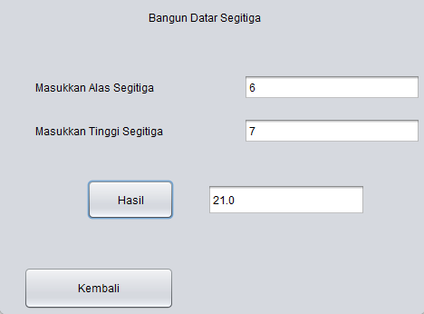

* **Persegi**

/*

* To change this license header, choose License Headers in Project Properties.

* To change this template file, choose Tools | Templates

* and open the template in the editor.

*/

/**

*

* @author Suci Indah Lestari

*/

public class persegi extends javax.swing.JFrame {

/**

* Creates new form persegi

*/

public persegi() {

initComponents();

}

/**

* This method is called from within the constructor to initialize the form.

* WARNING: Do NOT modify this code. The content of this method is always

* regenerated by the Form Editor.

*/

@SuppressWarnings("unchecked")

// <editor-fold defaultstate="collapsed" desc="Generated Code">

private void initComponents() {

jLabel1 = new javax.swing.JLabel();

angka1 = new javax.swing.JTextField();

jButton1 = new javax.swing.JButton();

hasil1 = new javax.swing.JTextField();

jLabel3 = new javax.swing.JLabel();

jButton2 = new javax.swing.JButton();

setDefaultCloseOperation(javax.swing.WindowConstants.EXIT_ON_CLOSE);

jLabel1.setText("Masukan Sisi ");

jButton1.setText("Hasil");

jButton1.addMouseListener(new java.awt.event.MouseAdapter() {

public void mouseClicked(java.awt.event.MouseEvent evt) {

jButton1MouseClicked(evt);

}

});

jLabel3.setText("Bangun Datar Persegi");

jButton2.setText("Kembali");

jButton2.addMouseListener(new java.awt.event.MouseAdapter() {

public void mouseClicked(java.awt.event.MouseEvent evt) {

jButton2MouseClicked(evt);

}

});

javax.swing.GroupLayout layout = new javax.swing.GroupLayout(getContentPane());

getContentPane().setLayout(layout);

layout.setHorizontalGroup(

layout.createParallelGroup(javax.swing.GroupLayout.Alignment.LEADING)

.addGroup(javax.swing.GroupLayout.Alignment.TRAILING, layout.createSequentialGroup()

.addContainerGap()

.addComponent(jButton1, javax.swing.GroupLayout.PREFERRED_SIZE, 107, javax.swing.GroupLayout.PREFERRED_SIZE)

.addGap(34, 34, 34)

.addComponent(hasil1, javax.swing.GroupLayout.DEFAULT_SIZE, 235, Short.MAX_VALUE)

.addContainerGap())

.addGroup(javax.swing.GroupLayout.Alignment.TRAILING, layout.createSequentialGroup()

.addContainerGap(javax.swing.GroupLayout.DEFAULT_SIZE, Short.MAX_VALUE)

.addComponent(jLabel3, javax.swing.GroupLayout.PREFERRED_SIZE, 209, javax.swing.GroupLayout.PREFERRED_SIZE)

.addGap(72, 72, 72))

.addGroup(layout.createSequentialGroup()

.addGroup(layout.createParallelGroup(javax.swing.GroupLayout.Alignment.LEADING)

.addGroup(layout.createSequentialGroup()

.addGap(53, 53, 53)

.addComponent(jLabel1, javax.swing.GroupLayout.PREFERRED_SIZE, 99, javax.swing.GroupLayout.PREFERRED_SIZE)

.addGap(65, 65, 65)

.addComponent(angka1, javax.swing.GroupLayout.PREFERRED_SIZE, 152, javax.swing.GroupLayout.PREFERRED_SIZE))

.addGroup(layout.createSequentialGroup()

.addGap(29, 29, 29)

.addComponent(jButton2, javax.swing.GroupLayout.PREFERRED_SIZE, 166, javax.swing.GroupLayout.PREFERRED_SIZE)))

.addContainerGap(javax.swing.GroupLayout.DEFAULT_SIZE, Short.MAX_VALUE))

);

layout.setVerticalGroup(

layout.createParallelGroup(javax.swing.GroupLayout.Alignment.LEADING)

.addGroup(layout.createSequentialGroup()

.addGap(32, 32, 32)

.addComponent(jLabel3)

.addGap(54, 54, 54)

.addGroup(layout.createParallelGroup(javax.swing.GroupLayout.Alignment.BASELINE)

.addComponent(jLabel1)

.addComponent(angka1, javax.swing.GroupLayout.PREFERRED_SIZE, 32, javax.swing.GroupLayout.PREFERRED_SIZE))

.addGap(40, 40, 40)

.addGroup(layout.createParallelGroup(javax.swing.GroupLayout.Alignment.LEADING)

.addComponent(jButton1, javax.swing.GroupLayout.PREFERRED_SIZE, 51, javax.swing.GroupLayout.PREFERRED_SIZE)

.addGroup(layout.createSequentialGroup()

.addGap(9, 9, 9)

.addComponent(hasil1, javax.swing.GroupLayout.PREFERRED_SIZE, 32, javax.swing.GroupLayout.PREFERRED_SIZE)))

.addPreferredGap(javax.swing.LayoutStyle.ComponentPlacement.RELATED, 63, Short.MAX_VALUE)

.addComponent(jButton2, javax.swing.GroupLayout.PREFERRED_SIZE, 47, javax.swing.GroupLayout.PREFERRED_SIZE)

.addGap(22, 22, 22))

);

pack();

}// </editor-fold>

private void jButton1MouseClicked(java.awt.event.MouseEvent evt) {

// TODO add your handling code here:

double Sisi, Luas;

Sisi= Double.parseDouble(angka1.getText());

Luas = Sisi * Sisi;

hasil1.setText(String.valueOf(Luas));

}

private void jButton2MouseClicked(java.awt.event.MouseEvent evt) {

// TODO add your handling code here:

bangun bg = new bangun();

bg.setVisible(true);

}

/**

* @param args the command line arguments

*/

public static void main(String args[]) {

/* Set the Nimbus look and feel */

//<editor-fold defaultstate="collapsed" desc=" Look and feel setting code (optional) ">

/* If Nimbus (introduced in Java SE 6) is not available, stay with the default look and feel.

* For details see http://download.oracle.com/javase/tutorial/uiswing/lookandfeel/plaf.html

*/

try {

for (javax.swing.UIManager.LookAndFeelInfo info : javax.swing.UIManager.getInstalledLookAndFeels()) {

if ("Nimbus".equals(info.getName())) {

javax.swing.UIManager.setLookAndFeel(info.getClassName());

break;

}

}

} catch (ClassNotFoundException ex) {

java.util.logging.Logger.getLogger(persegi.class.getName()).log(java.util.logging.Level.SEVERE, null, ex);

} catch (InstantiationException ex) {

java.util.logging.Logger.getLogger(persegi.class.getName()).log(java.util.logging.Level.SEVERE, null, ex);

} catch (IllegalAccessException ex) {

java.util.logging.Logger.getLogger(persegi.class.getName()).log(java.util.logging.Level.SEVERE, null, ex);

} catch (javax.swing.UnsupportedLookAndFeelException ex) {

java.util.logging.Logger.getLogger(persegi.class.getName()).log(java.util.logging.Level.SEVERE, null, ex);

}

//</editor-fold>

/* Create and display the form */

java.awt.EventQueue.invokeLater(new Runnable() {

public void run() {

new persegi().setVisible(true);

}

});

}

// Variables declaration - do not modify

private javax.swing.JTextField angka1;

private javax.swing.JTextField hasil1;

private javax.swing.JButton jButton1;

private javax.swing.JButton jButton2;

private javax.swing.JLabel jLabel1;

private javax.swing.JLabel jLabel3;

// End of variables declaration

}

**Hasil RUN**

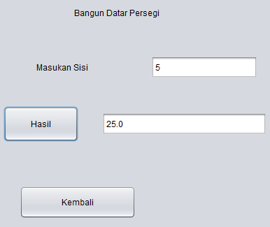

* **Lingkaran**

/*

* To change this license header, choose License Headers in Project Properties.

* To change this template file, choose Tools | Templates

* and open the template in the editor.

*/

/**

*

* @author Suci Indah Lestari

*/

public class lingkaran extends javax.swing.JFrame {

/**

* Creates new form lingkaran

*/

public lingkaran() {

initComponents();

}

/**

* This method is called from within the constructor to initialize the form.

* WARNING: Do NOT modify this code. The content of this method is always

* regenerated by the Form Editor.

*/

@SuppressWarnings("unchecked")

// <editor-fold defaultstate="collapsed" desc="Generated Code">

private void initComponents() {

angka1 = new javax.swing.JTextField();

jLabel1 = new javax.swing.JLabel();

hasil = new javax.swing.JButton();

hasil1 = new javax.swing.JTextField();

jLabel3 = new javax.swing.JLabel();

jButton2 = new javax.swing.JButton();

setDefaultCloseOperation(javax.swing.WindowConstants.EXIT_ON_CLOSE);

jLabel1.setText("Masukkan Jari-Jari");

hasil.setText("Hasil");

hasil.addMouseListener(new java.awt.event.MouseAdapter() {

public void mouseClicked(java.awt.event.MouseEvent evt) {

hasilMouseClicked(evt);

}

});

jLabel3.setText("Bangun Datar Lingkaran");

jButton2.setText("Kembali");

jButton2.addMouseListener(new java.awt.event.MouseAdapter() {

public void mouseClicked(java.awt.event.MouseEvent evt) {

jButton2MouseClicked(evt);

}

});

javax.swing.GroupLayout layout = new javax.swing.GroupLayout(getContentPane());

getContentPane().setLayout(layout);

layout.setHorizontalGroup(

layout.createParallelGroup(javax.swing.GroupLayout.Alignment.LEADING)

.addGroup(javax.swing.GroupLayout.Alignment.TRAILING, layout.createSequentialGroup()

.addContainerGap(javax.swing.GroupLayout.DEFAULT_SIZE, Short.MAX_VALUE)

.addComponent(jLabel3, javax.swing.GroupLayout.PREFERRED_SIZE, 209, javax.swing.GroupLayout.PREFERRED_SIZE)

.addGap(80, 80, 80))

.addGroup(layout.createSequentialGroup()

.addGap(25, 25, 25)

.addGroup(layout.createParallelGroup(javax.swing.GroupLayout.Alignment.LEADING)

.addGroup(layout.createSequentialGroup()

.addComponent(jButton2, javax.swing.GroupLayout.PREFERRED_SIZE, 166, javax.swing.GroupLayout.PREFERRED_SIZE)

.addGap(0, 0, Short.MAX_VALUE))

.addGroup(layout.createSequentialGroup()

.addComponent(jLabel1, javax.swing.GroupLayout.PREFERRED_SIZE, 153, javax.swing.GroupLayout.PREFERRED_SIZE)

.addGap(77, 77, 77)

.addComponent(angka1, javax.swing.GroupLayout.DEFAULT_SIZE, 149, Short.MAX_VALUE))

.addGroup(javax.swing.GroupLayout.Alignment.TRAILING, layout.createSequentialGroup()

.addPreferredGap(javax.swing.LayoutStyle.ComponentPlacement.RELATED, 34, javax.swing.GroupLayout.PREFERRED_SIZE)

.addComponent(hasil, javax.swing.GroupLayout.PREFERRED_SIZE, 96, javax.swing.GroupLayout.PREFERRED_SIZE)

.addGap(37, 37, 37)

.addComponent(hasil1, javax.swing.GroupLayout.PREFERRED_SIZE, 174, javax.swing.GroupLayout.PREFERRED_SIZE)

.addGap(23, 23, 23)))

.addContainerGap())

);

layout.setVerticalGroup(

layout.createParallelGroup(javax.swing.GroupLayout.Alignment.LEADING)

.addGroup(layout.createSequentialGroup()

.addGap(33, 33, 33)

.addComponent(jLabel3)

.addGap(42, 42, 42)

.addGroup(layout.createParallelGroup(javax.swing.GroupLayout.Alignment.BASELINE)

.addComponent(jLabel1, javax.swing.GroupLayout.PREFERRED_SIZE, 36, javax.swing.GroupLayout.PREFERRED_SIZE)

.addComponent(angka1, javax.swing.GroupLayout.PREFERRED_SIZE, javax.swing.GroupLayout.DEFAULT_SIZE, javax.swing.GroupLayout.PREFERRED_SIZE))

.addGap(48, 48, 48)

.addGroup(layout.createParallelGroup(javax.swing.GroupLayout.Alignment.BASELINE)

.addComponent(hasil, javax.swing.GroupLayout.PREFERRED_SIZE, 44, javax.swing.GroupLayout.PREFERRED_SIZE)

.addComponent(hasil1, javax.swing.GroupLayout.PREFERRED_SIZE, 34, javax.swing.GroupLayout.PREFERRED_SIZE))

.addPreferredGap(javax.swing.LayoutStyle.ComponentPlacement.RELATED, 72, Short.MAX_VALUE)

.addComponent(jButton2, javax.swing.GroupLayout.PREFERRED_SIZE, 47, javax.swing.GroupLayout.PREFERRED_SIZE)

.addGap(24, 24, 24))

);

pack();

}// </editor-fold>

private void hasilMouseClicked(java.awt.event.MouseEvent evt) {

// TODO add your handling code here:

double JariJari, Luas;

JariJari= Double.parseDouble(angka1.getText());

Luas = Math.PI * Math.pow(JariJari,2);

hasil1.setText(String.format("%.2f", Luas));

}

private void jButton2MouseClicked(java.awt.event.MouseEvent evt) {

// TODO add your handling code here:

bangun bg = new bangun();

bg.setVisible(true);

}

/**

* @param args the command line arguments

*/

public static void main(String args[]) {

/* Set the Nimbus look and feel */

//<editor-fold defaultstate="collapsed" desc=" Look and feel setting code (optional) ">

/* If Nimbus (introduced in Java SE 6) is not available, stay with the default look and feel.

* For details see http://download.oracle.com/javase/tutorial/uiswing/lookandfeel/plaf.html

*/

try {

for (javax.swing.UIManager.LookAndFeelInfo info : javax.swing.UIManager.getInstalledLookAndFeels()) {

if ("Nimbus".equals(info.getName())) {

javax.swing.UIManager.setLookAndFeel(info.getClassName());

break;

}

}

} catch (ClassNotFoundException ex) {

java.util.logging.Logger.getLogger(lingkaran.class.getName()).log(java.util.logging.Level.SEVERE, null, ex);

} catch (InstantiationException ex) {

java.util.logging.Logger.getLogger(lingkaran.class.getName()).log(java.util.logginangka1RE, null, ex);

} catch (IllegalAccessException ex) {

java.util.logging.Logger.getLogger(lingkaran.class.getName()).log(java.util.logging.Level.SEVERE, null, ex);

} catch (javax.swing.UnsupportedLookAndFeelException ex) {

java.util.logging.Logger.getLogger(lingkaran.class.getName()).log(java.util.logging.Level.SEVERE, null, ex);

}

//</editor-fold>

/* Create and display the form */

java.awt.EventQueue.invokeLater(new Runnable() {

public void run() {

new lingkaran().setVisible(true);

}

});

}

// Variables declaration - do not modify

private javax.swing.JTextField angka1;

private javax.swing.JButton hasil;

private javax.swing.JTextField hasil1;

private javax.swing.JButton jButton2;

private javax.swing.JLabel jLabel1;

private javax.swing.JLabel jLabel3;

// End of variables declaration

}

**Hasil RUN**

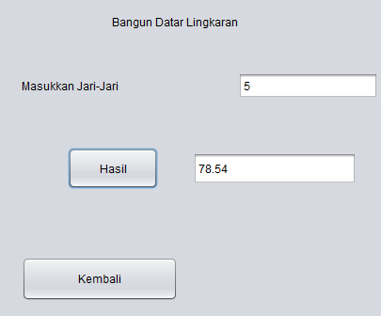

* **Kubus**

/*

* To change this license header, choose License Headers in Project Properties.

* To change this template file, choose Tools | Templates

* and open the template in the editor.

*/

/**

*

* @author Suci Indah Lestari

*/

public class kubus extends javax.swing.JFrame {

/**

* Creates new form kubus

*/

public kubus() {

initComponents();

}

/**

* This method is called from within the constructor to initialize the form.

* WARNING: Do NOT modify this code. The content of this method is always

* regenerated by the Form Editor.

*/

@SuppressWarnings("unchecked")

// <editor-fold defaultstate="collapsed" desc="Generated Code">

private void initComponents() {

jButton2 = new javax.swing.JButton();

angka1 = new javax.swing.JTextField();

jLabel1 = new javax.swing.JLabel();

jButton1 = new javax.swing.JButton();

hasil1 = new javax.swing.JTextField();

jLabel3 = new javax.swing.JLabel();

jButton3 = new javax.swing.JButton();

jButton2.setText("Kembali");

jButton2.addMouseListener(new java.awt.event.MouseAdapter() {

public void mouseClicked(java.awt.event.MouseEvent evt) {

jButton2MouseClicked(evt);

}

});

setDefaultCloseOperation(javax.swing.WindowConstants.EXIT_ON_CLOSE);

jLabel1.setText("Masukan Sisi ");

jButton1.setText("Hasil");

jButton1.addMouseListener(new java.awt.event.MouseAdapter() {

public void mouseClicked(java.awt.event.MouseEvent evt) {

jButton1MouseClicked(evt);

}

});

jLabel3.setText("Bangun Ruang Kubus");

jButton3.setText("Kembali");

jButton3.addMouseListener(new java.awt.event.MouseAdapter() {

public void mouseClicked(java.awt.event.MouseEvent evt) {

jButton3MouseClicked(evt);

}

});

javax.swing.GroupLayout layout = new javax.swing.GroupLayout(getContentPane());

getContentPane().setLayout(layout);

layout.setHorizontalGroup(

layout.createParallelGroup(javax.swing.GroupLayout.Alignment.LEADING)

.addGroup(javax.swing.GroupLayout.Alignment.TRAILING, layout.createSequentialGroup()

.addContainerGap()

.addComponent(jButton1, javax.swing.GroupLayout.PREFERRED_SIZE, 107, javax.swing.GroupLayout.PREFERRED_SIZE)

.addGap(34, 34, 34)

.addComponent(hasil1, javax.swing.GroupLayout.DEFAULT_SIZE, 235, Short.MAX_VALUE)

.addContainerGap())

.addGroup(javax.swing.GroupLayout.Alignment.TRAILING, layout.createSequentialGroup()

.addContainerGap(javax.swing.GroupLayout.DEFAULT_SIZE, Short.MAX_VALUE)

.addComponent(jLabel3, javax.swing.GroupLayout.PREFERRED_SIZE, 209, javax.swing.GroupLayout.PREFERRED_SIZE)

.addGap(84, 84, 84))

.addGroup(layout.createSequentialGroup()

.addGroup(layout.createParallelGroup(javax.swing.GroupLayout.Alignment.LEADING)

.addGroup(layout.createSequentialGroup()

.addGap(53, 53, 53)

.addComponent(jLabel1, javax.swing.GroupLayout.PREFERRED_SIZE, 99, javax.swing.GroupLayout.PREFERRED_SIZE)

.addGap(65, 65, 65)

.addComponent(angka1, javax.swing.GroupLayout.PREFERRED_SIZE, 152, javax.swing.GroupLayout.PREFERRED_SIZE))

.addGroup(layout.createSequentialGroup()

.addGap(23, 23, 23)

.addComponent(jButton3, javax.swing.GroupLayout.PREFERRED_SIZE, 166, javax.swing.GroupLayout.PREFERRED_SIZE)))

.addContainerGap(javax.swing.GroupLayout.DEFAULT_SIZE, Short.MAX_VALUE))

);

layout.setVerticalGroup(

layout.createParallelGroup(javax.swing.GroupLayout.Alignment.LEADING)

.addGroup(layout.createSequentialGroup()

.addGap(33, 33, 33)

.addComponent(jLabel3)

.addGap(36, 36, 36)

.addGroup(layout.createParallelGroup(javax.swing.GroupLayout.Alignment.BASELINE)

.addComponent(jLabel1)

.addComponent(angka1, javax.swing.GroupLayout.PREFERRED_SIZE, 32, javax.swing.GroupLayout.PREFERRED_SIZE))

.addGap(40, 40, 40)

.addGroup(layout.createParallelGroup(javax.swing.GroupLayout.Alignment.LEADING)

.addComponent(jButton1, javax.swing.GroupLayout.PREFERRED_SIZE, 51, javax.swing.GroupLayout.PREFERRED_SIZE)

.addGroup(layout.createSequentialGroup()

.addGap(9, 9, 9)

.addComponent(hasil1, javax.swing.GroupLayout.PREFERRED_SIZE, 32, javax.swing.GroupLayout.PREFERRED_SIZE)))

.addPreferredGap(javax.swing.LayoutStyle.ComponentPlacement.RELATED, 71, Short.MAX_VALUE)

.addComponent(jButton3, javax.swing.GroupLayout.PREFERRED_SIZE, 47, javax.swing.GroupLayout.PREFERRED_SIZE)

.addGap(21, 21, 21))

);

pack();

}// </editor-fold>

private void jButton1MouseClicked(java.awt.event.MouseEvent evt) {

// TODO add your handling code here:

double Sisi, Luas;

Sisi= Double.parseDouble(angka1.getText());

Luas = Sisi * Sisi * Sisi;

hasil1.setText(String.valueOf(Luas));

}

private void jButton2MouseClicked(java.awt.event.MouseEvent evt) {

// TODO add your handling code here:

bangun bg = new bangun();

bg.setVisible(true);

}

private void jButton3MouseClicked(java.awt.event.MouseEvent evt) {

// TODO add your handling code here:

bangun bg = new bangun();

bg.setVisible(true);

}

/**

* @param args the command line arguments

*/

public static void main(String args[]) {

/* Set the Nimbus look and feel */

//<editor-fold defaultstate="collapsed" desc=" Look and feel setting code (optional) ">

/* If Nimbus (introduced in Java SE 6) is not available, stay with the default look and feel.

* For details see http://download.oracle.com/javase/tutorial/uiswing/lookandfeel/plaf.html

*/

try {

for (javax.swing.UIManager.LookAndFeelInfo info : javax.swing.UIManager.getInstalledLookAndFeels()) {

if ("Nimbus".equals(info.getName())) {

javax.swing.UIManager.setLookAndFeel(info.getClassName());

break;

}

}

} catch (ClassNotFoundException ex) {

java.util.logging.Logger.getLogger(kubus.class.getName()).log(java.util.logging.Level.SEVERE, null, ex);

} catch (InstantiationException ex) {

java.util.logging.Logger.getLogger(kubus.class.getName()).log(java.util.logging.Level.SEVERE, null, ex);

} catch (IllegalAccessException ex) {

java.util.logging.Logger.getLogger(kubus.class.getName()).log(java.util.logging.Level.SEVERE, null, ex);

} catch (javax.swing.UnsupportedLookAndFeelException ex) {

java.util.logging.Logger.getLogger(kubus.class.getName()).log(java.util.logging.Level.SEVERE, null, ex);

}

//</editor-fold>

/* Create and display the form */

java.awt.EventQueue.invokeLater(new Runnable() {

public void run() {

new kubus().setVisible(true);

}

});

}

// Variables declaration - do not modify

private javax.swing.JTextField angka1;

private javax.swing.JTextField hasil1;

private javax.swing.JButton jButton1;

private javax.swing.JButton jButton2;

private javax.swing.JButton jButton3;

private javax.swing.JLabel jLabel1;

private javax.swing.JLabel jLabel3;

// End of variables declaration

}

**Hasil RUN**

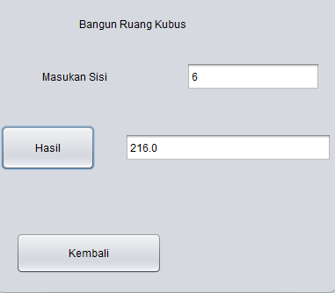

* **Balok**

/*

* To change this license header, choose License Headers in Project Properties.

* To change this template file, choose Tools | Templates

* and open the template in the editor.

*/

/**

*

* @author Suci Indah Lestari

*/

public class balok extends javax.swing.JFrame {

/**

* Creates new form balok

*/

public balok() {

initComponents();

}

/**

* This method is called from within the constructor to initialize the form.

* WARNING: Do NOT modify this code. The content of this method is always

* regenerated by the Form Editor.

*/

@SuppressWarnings("unchecked")

// <editor-fold defaultstate="collapsed" desc="Generated Code">

private void initComponents() {

jLabel1 = new javax.swing.JLabel();

angka1 = new javax.swing.JTextField();

jButton1 = new javax.swing.JButton();

hasil1 = new javax.swing.JTextField();

jLabel2 = new javax.swing.JLabel();

angka2 = new javax.swing.JTextField();

jLabel3 = new javax.swing.JLabel();

angka3 = new javax.swing.JTextField();

jLabel4 = new javax.swing.JLabel();

jButton3 = new javax.swing.JButton();

setDefaultCloseOperation(javax.swing.WindowConstants.EXIT_ON_CLOSE);

jLabel1.setText("Masukan Panjang");

jButton1.setText("Hasil");

jButton1.addMouseListener(new java.awt.event.MouseAdapter() {

public void mouseClicked(java.awt.event.MouseEvent evt) {

jButton1MouseClicked(evt);

}

});

jLabel2.setText("Masukan Lebar");

jLabel3.setText("Masukan Tinggi");

jLabel4.setText("Bangun Ruang Balok");

jButton3.setText("Kembali");

jButton3.addMouseListener(new java.awt.event.MouseAdapter() {

public void mouseClicked(java.awt.event.MouseEvent evt) {

jButton3MouseClicked(evt);

}

});

javax.swing.GroupLayout layout = new javax.swing.GroupLayout(getContentPane());

getContentPane().setLayout(layout);

layout.setHorizontalGroup(

layout.createParallelGroup(javax.swing.GroupLayout.Alignment.LEADING)

.addGroup(javax.swing.GroupLayout.Alignment.TRAILING, layout.createSequentialGroup()

.addContainerGap()

.addComponent(jButton1, javax.swing.GroupLayout.PREFERRED_SIZE, 107, javax.swing.GroupLayout.PREFERRED_SIZE)

.addGap(34, 34, 34)

.addComponent(hasil1, javax.swing.GroupLayout.DEFAULT_SIZE, 235, Short.MAX_VALUE)

.addContainerGap())

.addGroup(javax.swing.GroupLayout.Alignment.TRAILING, layout.createSequentialGroup()

.addContainerGap(javax.swing.GroupLayout.DEFAULT_SIZE, Short.MAX_VALUE)

.addComponent(jLabel4, javax.swing.GroupLayout.PREFERRED_SIZE, 209, javax.swing.GroupLayout.PREFERRED_SIZE)

.addGap(73, 73, 73))

.addGroup(layout.createSequentialGroup()

.addGroup(layout.createParallelGroup(javax.swing.GroupLayout.Alignment.LEADING)

.addGroup(layout.createSequentialGroup()

.addGap(53, 53, 53)

.addGroup(layout.createParallelGroup(javax.swing.GroupLayout.Alignment.TRAILING, false)

.addGroup(layout.createSequentialGroup()

.addComponent(jLabel3, javax.swing.GroupLayout.PREFERRED_SIZE, 99, javax.swing.GroupLayout.PREFERRED_SIZE)

.addGap(65, 65, 65)

.addComponent(angka3, javax.swing.GroupLayout.PREFERRED_SIZE, 152, javax.swing.GroupLayout.PREFERRED_SIZE))

.addGroup(layout.createSequentialGroup()

.addComponent(jLabel2, javax.swing.GroupLayout.PREFERRED_SIZE, 99, javax.swing.GroupLayout.PREFERRED_SIZE)

.addGap(65, 65, 65)

.addComponent(angka2, javax.swing.GroupLayout.PREFERRED_SIZE, 152, javax.swing.GroupLayout.PREFERRED_SIZE))

.addGroup(layout.createSequentialGroup()

.addComponent(jLabel1, javax.swing.GroupLayout.PREFERRED_SIZE, 116, javax.swing.GroupLayout.PREFERRED_SIZE)

.addPreferredGap(javax.swing.LayoutStyle.ComponentPlacement.RELATED, javax.swing.GroupLayout.DEFAULT_SIZE, Short.MAX_VALUE)

.addComponent(angka1, javax.swing.GroupLayout.PREFERRED_SIZE, 152, javax.swing.GroupLayout.PREFERRED_SIZE))))

.addGroup(layout.createSequentialGroup()

.addGap(25, 25, 25)

.addComponent(jButton3, javax.swing.GroupLayout.PREFERRED_SIZE, 166, javax.swing.GroupLayout.PREFERRED_SIZE)))

.addContainerGap(javax.swing.GroupLayout.DEFAULT_SIZE, Short.MAX_VALUE))

);

layout.setVerticalGroup(

layout.createParallelGroup(javax.swing.GroupLayout.Alignment.LEADING)

.addGroup(layout.createSequentialGroup()

.addGap(38, 38, 38)

.addComponent(jLabel4)

.addGap(31, 31, 31)

.addGroup(layout.createParallelGroup(javax.swing.GroupLayout.Alignment.BASELINE)

.addComponent(jLabel1)

.addComponent(angka1, javax.swing.GroupLayout.PREFERRED_SIZE, 32, javax.swing.GroupLayout.PREFERRED_SIZE))

.addGap(26, 26, 26)

.addGroup(layout.createParallelGroup(javax.swing.GroupLayout.Alignment.BASELINE)

.addComponent(jLabel2)

.addComponent(angka2, javax.swing.GroupLayout.PREFERRED_SIZE, 32, javax.swing.GroupLayout.PREFERRED_SIZE))

.addGap(31, 31, 31)

.addGroup(layout.createParallelGroup(javax.swing.GroupLayout.Alignment.BASELINE)

.addComponent(jLabel3)

.addComponent(angka3, javax.swing.GroupLayout.PREFERRED_SIZE, 32, javax.swing.GroupLayout.PREFERRED_SIZE))

.addGap(39, 39, 39)

.addGroup(layout.createParallelGroup(javax.swing.GroupLayout.Alignment.LEADING)

.addComponent(jButton1, javax.swing.GroupLayout.PREFERRED_SIZE, 51, javax.swing.GroupLayout.PREFERRED_SIZE)

.addGroup(layout.createSequentialGroup()

.addGap(9, 9, 9)

.addComponent(hasil1, javax.swing.GroupLayout.PREFERRED_SIZE, 32, javax.swing.GroupLayout.PREFERRED_SIZE)))

.addPreferredGap(javax.swing.LayoutStyle.ComponentPlacement.RELATED, 70, Short.MAX_VALUE)

.addComponent(jButton3, javax.swing.GroupLayout.PREFERRED_SIZE, 47, javax.swing.GroupLayout.PREFERRED_SIZE)

.addGap(23, 23, 23))

);

pack();

}// </editor-fold>

private void jButton1MouseClicked(java.awt.event.MouseEvent evt) {

// TODO add your handling code here:

double Panjang,Lebar, Tinggi, Volume;

Panjang= Double.parseDouble(angka1.getText());

Lebar= Double.parseDouble(angka2.getText());

Tinggi= Double.parseDouble(angka3.getText());

Volume = Panjang * Lebar * Tinggi;

hasil1.setText(String.valueOf(Volume));

}

private void jButton3MouseClicked(java.awt.event.MouseEvent evt) {

// TODO add your handling code here:

bangun bg = new bangun();

bg.setVisible(true);

}

/**

* @param args the command line arguments

*/

public static void main(String args[]) {

/* Set the Nimbus look and feel */

//<editor-fold defaultstate="collapsed" desc=" Look and feel setting code (optional) ">

/* If Nimbus (introduced in Java SE 6) is not available, stay with the default look and feel.

* For details see http://download.oracle.com/javase/tutorial/uiswing/lookandfeel/plaf.html

*/

try {

for (javax.swing.UIManager.LookAndFeelInfo info : javax.swing.UIManager.getInstalledLookAndFeels()) {

if ("Nimbus".equals(info.getName())) {

javax.swing.UIManager.setLookAndFeel(info.getClassName());

break;

}

}

} catch (ClassNotFoundException ex) {

java.util.logging.Logger.getLogger(balok.class.getName()).log(java.util.logging.Level.SEVERE, null, ex);

} catch (InstantiationException ex) {

java.util.logging.Logger.getLogger(balok.class.getName()).log(java.util.logging.Level.SEVERE, null, ex);

} catch (IllegalAccessException ex) {

java.util.logging.Logger.getLogger(balok.class.getName()).log(java.util.logging.Level.SEVERE, null, ex);

} catch (javax.swing.UnsupportedLookAndFeelException ex) {

java.util.logging.Logger.getLogger(balok.class.getName()).log(java.util.logging.Level.SEVERE, null, ex);

}

//</editor-fold>

/* Create and display the form */

java.awt.EventQueue.invokeLater(new Runnable() {

public void run() {

new balok().setVisible(true);

}

});

}

// Variables declaration - do not modify

private javax.swing.JTextField angka1;

private javax.swing.JTextField angka2;

private javax.swing.JTextField angka3;

private javax.swing.JTextField hasil1;

private javax.swing.JButton jButton1;

private javax.swing.JButton jButton3;

private javax.swing.JLabel jLabel1;

private javax.swing.JLabel jLabel2;

private javax.swing.JLabel jLabel3;

private javax.swing.JLabel jLabel4;

// End of variables declaration

}

**Hasil RUN**

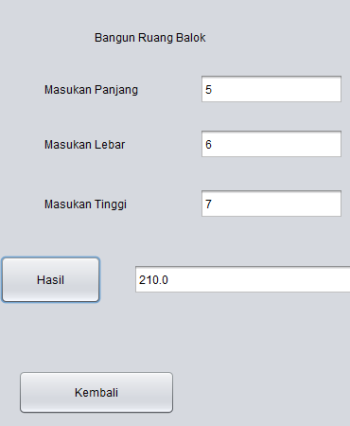

* **Tabung**

/*

* To change this license header, choose License Headers in Project Properties.

* To change this template file, choose Tools | Templates

* and open the template in the editor.

*/

/**

*

* @author Suci Indah Lestari

*/

public class tabung extends javax.swing.JFrame {

/**

* Creates new form tabung

*/

public tabung() {

initComponents();

}

/**

* This method is called from within the constructor to initialize the form.

* WARNING: Do NOT modify this code. The content of this method is always

* regenerated by the Form Editor.

*/

@SuppressWarnings("unchecked")

// <editor-fold defaultstate="collapsed" desc="Generated Code">

private void initComponents() {

jLabel1 = new javax.swing.JLabel();

angka1 = new javax.swing.JTextField();

jLabel2 = new javax.swing.JLabel();

angka2 = new javax.swing.JTextField();

hasil = new javax.swing.JButton();

hasil1 = new javax.swing.JTextField();

jLabel4 = new javax.swing.JLabel();

jButton3 = new javax.swing.JButton();

setDefaultCloseOperation(javax.swing.WindowConstants.EXIT_ON_CLOSE);

jLabel1.setText("Masukkan Jari-Jari");

jLabel2.setText("Masukkan Tinggi");

hasil.setText("Hasil");

hasil.addMouseListener(new java.awt.event.MouseAdapter() {

public void mouseClicked(java.awt.event.MouseEvent evt) {

hasilMouseClicked(evt);

}

});

jLabel4.setText("Bangun Ruang Tabung");

jButton3.setText("Kembali");

jButton3.addMouseListener(new java.awt.event.MouseAdapter() {

public void mouseClicked(java.awt.event.MouseEvent evt) {

jButton3MouseClicked(evt);

}

});

javax.swing.GroupLayout layout = new javax.swing.GroupLayout(getContentPane());

getContentPane().setLayout(layout);

layout.setHorizontalGroup(

layout.createParallelGroup(javax.swing.GroupLayout.Alignment.LEADING)

.addGroup(layout.createSequentialGroup()

.addGap(40, 40, 40)

.addGroup(layout.createParallelGroup(javax.swing.GroupLayout.Alignment.LEADING)

.addGroup(layout.createSequentialGroup()

.addComponent(jLabel1, javax.swing.GroupLayout.PREFERRED_SIZE, 153, javax.swing.GroupLayout.PREFERRED_SIZE)

.addGap(77, 77, 77)

.addComponent(angka1))

.addGroup(layout.createSequentialGroup()

.addGroup(layout.createParallelGroup(javax.swing.GroupLayout.Alignment.TRAILING)

.addComponent(hasil, javax.swing.GroupLayout.PREFERRED_SIZE, 96, javax.swing.GroupLayout.PREFERRED_SIZE)

.addComponent(jLabel2, javax.swing.GroupLayout.PREFERRED_SIZE, 153, javax.swing.GroupLayout.PREFERRED_SIZE))

.addGroup(layout.createParallelGroup(javax.swing.GroupLayout.Alignment.LEADING)

.addGroup(layout.createSequentialGroup()

.addGap(77, 77, 77)

.addComponent(angka2))

.addGroup(layout.createSequentialGroup()

.addGap(37, 37, 37)

.addComponent(hasil1, javax.swing.GroupLayout.PREFERRED_SIZE, 174, javax.swing.GroupLayout.PREFERRED_SIZE)

.addGap(0, 0, Short.MAX_VALUE)))))

.addContainerGap())

.addGroup(javax.swing.GroupLayout.Alignment.TRAILING, layout.createSequentialGroup()

.addContainerGap(javax.swing.GroupLayout.DEFAULT_SIZE, Short.MAX_VALUE)

.addComponent(jLabel4, javax.swing.GroupLayout.PREFERRED_SIZE, 209, javax.swing.GroupLayout.PREFERRED_SIZE)

.addGap(65, 65, 65))

.addGroup(layout.createSequentialGroup()

.addContainerGap()

.addComponent(jButton3, javax.swing.GroupLayout.PREFERRED_SIZE, 166, javax.swing.GroupLayout.PREFERRED_SIZE)

.addContainerGap(javax.swing.GroupLayout.DEFAULT_SIZE, Short.MAX_VALUE))

);

layout.setVerticalGroup(

layout.createParallelGroup(javax.swing.GroupLayout.Alignment.LEADING)

.addGroup(layout.createSequentialGroup()

.addGap(42, 42, 42)

.addComponent(jLabel4)

.addGap(32, 32, 32)

.addGroup(layout.createParallelGroup(javax.swing.GroupLayout.Alignment.BASELINE)

.addComponent(jLabel1, javax.swing.GroupLayout.PREFERRED_SIZE, 36, javax.swing.GroupLayout.PREFERRED_SIZE)

.addComponent(angka1, javax.swing.GroupLayout.PREFERRED_SIZE, javax.swing.GroupLayout.DEFAULT_SIZE, javax.swing.GroupLayout.PREFERRED_SIZE))

.addPreferredGap(javax.swing.LayoutStyle.ComponentPlacement.UNRELATED)

.addGroup(layout.createParallelGroup(javax.swing.GroupLayout.Alignment.BASELINE)

.addComponent(jLabel2, javax.swing.GroupLayout.PREFERRED_SIZE, 36, javax.swing.GroupLayout.PREFERRED_SIZE)

.addComponent(angka2, javax.swing.GroupLayout.PREFERRED_SIZE, javax.swing.GroupLayout.DEFAULT_SIZE, javax.swing.GroupLayout.PREFERRED_SIZE))

.addGap(36, 36, 36)

.addGroup(layout.createParallelGroup(javax.swing.GroupLayout.Alignment.BASELINE)

.addComponent(hasil, javax.swing.GroupLayout.PREFERRED_SIZE, 44, javax.swing.GroupLayout.PREFERRED_SIZE)

.addComponent(hasil1, javax.swing.GroupLayout.PREFERRED_SIZE, 34, javax.swing.GroupLayout.PREFERRED_SIZE))

.addPreferredGap(javax.swing.LayoutStyle.ComponentPlacement.RELATED, 61, Short.MAX_VALUE)

.addComponent(jButton3, javax.swing.GroupLayout.PREFERRED_SIZE, 47, javax.swing.GroupLayout.PREFERRED_SIZE)

.addGap(30, 30, 30))

);

pack();

}// </editor-fold>

private void hasilMouseClicked(java.awt.event.MouseEvent evt) {

// TODO add your handling code here:

double JariJari, Tinggi, Volume;

JariJari= Double.parseDouble(angka1.getText());

Tinggi= Double.parseDouble(angka2.getText());

Volume = Math.PI * Math.pow(JariJari, 2) * Tinggi;

hasil1.setText(String.format("%.2f", Volume));

}

private void jButton3MouseClicked(java.awt.event.MouseEvent evt) {

// TODO add your handling code here:

bangun bg = new bangun();

bg.setVisible(true);

}

/**

* @param args the command line arguments

*/

public static void main(String args[]) {

/* Set the Nimbus look and feel */

//<editor-fold defaultstate="collapsed" desc=" Look and feel setting code (optional) ">

/* If Nimbus (introduced in Java SE 6) is not available, stay with the default look and feel.

* For details see http://download.oracle.com/javase/tutorial/uiswing/lookandfeel/plaf.html

*/

try {

for (javax.swing.UIManager.LookAndFeelInfo info : javax.swing.UIManager.getInstalledLookAndFeels()) {

if ("Nimbus".equals(info.getName())) {

javax.swing.UIManager.setLookAndFeel(info.getClassName());

break;

}

}

} catch (ClassNotFoundException ex) {

java.util.logging.Logger.getLogger(tabung.class.getName()).log(java.util.logging.Level.SEVERE, null, ex);

} catch (InstantiationException ex) {

java.util.logging.Logger.getLogger(tabung.class.getName()).log(java.util.logging.Level.SEVERE, null, ex);

} catch (IllegalAccessException ex) {

java.util.logging.Logger.getLogger(tabung.class.getName()).log(java.util.logging.Level.SEVERE, null, ex);

} catch (javax.swing.UnsupportedLookAndFeelException ex) {

java.util.logging.Logger.getLogger(tabung.class.getName()).log(java.util.logging.Level.SEVERE, null, ex);

}

//</editor-fold>

/* Create and display the form */

java.awt.EventQueue.invokeLater(new Runnable() {

public void run() {

new tabung().setVisible(true);

}

});

}

// Variables declaration - do not modify

private javax.swing.JTextField angka1;

private javax.swing.JTextField angka2;

private javax.swing.JButton hasil;

private javax.swing.JTextField hasil1;

private javax.swing.JButton jButton3;

private javax.swing.JLabel jLabel1;

private javax.swing.JLabel jLabel2;

private javax.swing.JLabel jLabel4;

// End of variables declaration

}

**Hasil RUN**

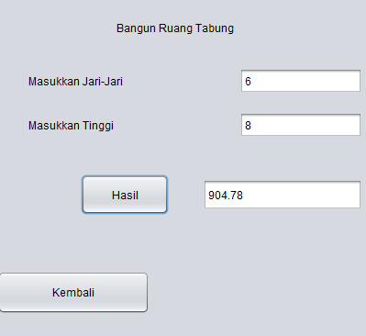

**PRETEST**

1. **Apa itu Swing Control ?**

**Jawab :** Swing Control adalah bagian dari Java Foundation Classes (JFC) yang digunakan untuk membuat aplikasi berbasis antarmuka grafis (GUI) di Java. Swing adalah toolkit grafis yang memungkinkan pengembang untuk menciptakan aplikasi dengan komponen visual seperti tombol, kotak teks, panel, dan lainnya.

1. **Fungsi dari Swing Control ?**

**Jawab :**

* Membuat antarmuka grafis yang konsisten di berbagai platform yang mendukung Java.
* Menggunakan berbagai komponen GUI seperti button, text field, panel, dan lainnya yang dapat disesuaikan sesuai kebutuhan.
* Mengelola event handling dengan baik, sehingga aplikasi dapat merespons interaksi pengguna seperti klik tombol atau pergerakan mouse.
* Menggunakan layout managers untuk mengatur posisi dan ukuran komponen dalam kontainer, memastikan tampilan yang konsisten di berbagai resolusi layer.

1. **Tuliskan Program sederhana untuk swing control!**

**Jawab :**

/*

* To change this license header, choose License Headers in Project Properties.

* To change this template file, choose Tools | Templates

* and open the template in the editor.

*/

import javax.swing.JFrame;

import javax.swing.JLabel;

/**

*

* @author Suci Indah Lestari

*/

public class well {

public static void main(String[] args) {

JFrame frame = new JFrame("Nama Lengkap");

frame.setDefaultCloseOperation(JFrame.EXIT_ON_CLOSE);

frame.setSize(300, 200);

frame.setVisible(true);

JLabel label = new JLabel("Mohamad Aban Sy'bana", JLabel.CENTER);

frame.add(label);

}

}

**PRAKTIKUM 1**

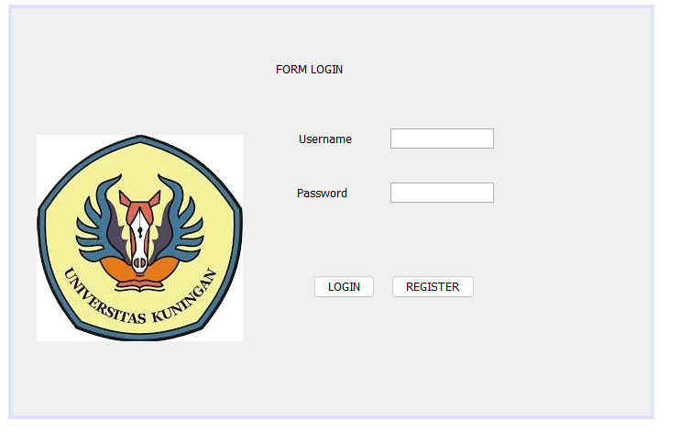

**PRAKTIKUM 2**

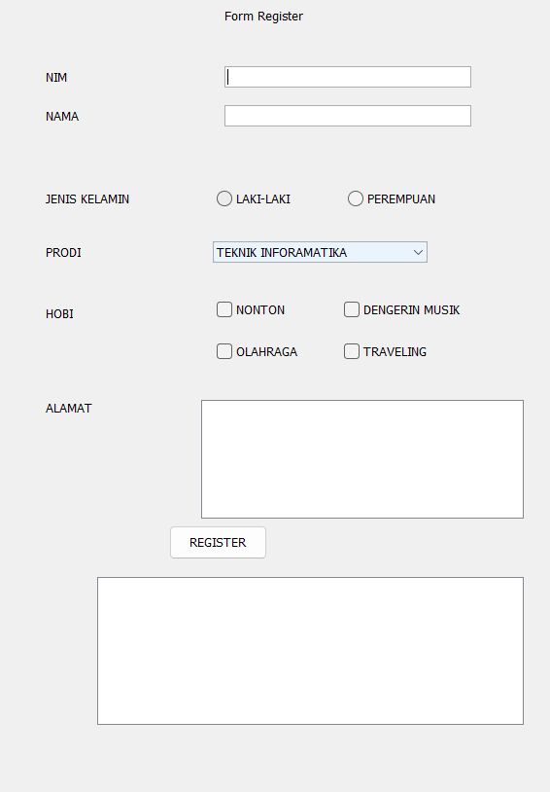

**POSTES**

1. **Lengkapi kondisi Login, Sehingga memiliki kondisi :**

* Jika username tidak di isi, maka akan menampilkan message “Username harus diisi”

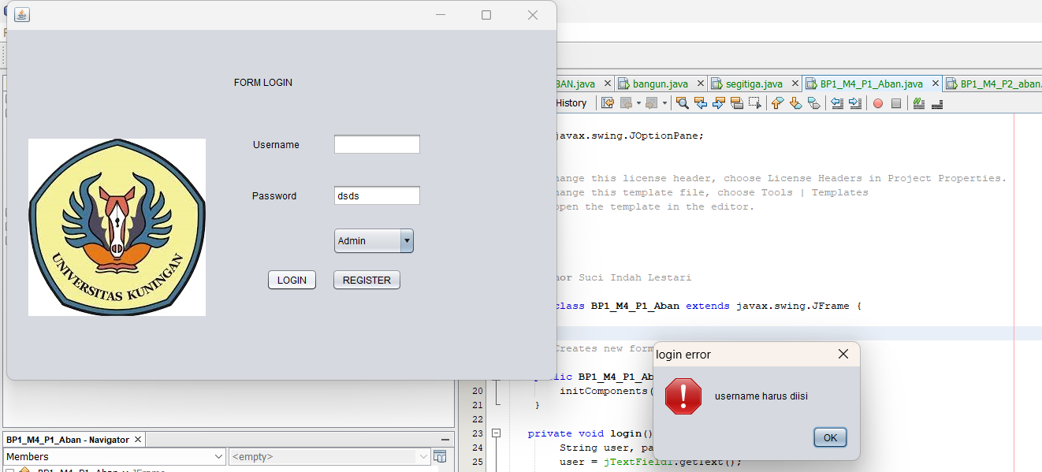

* Jika username salah, maka akan menampilkan message “Username salah”

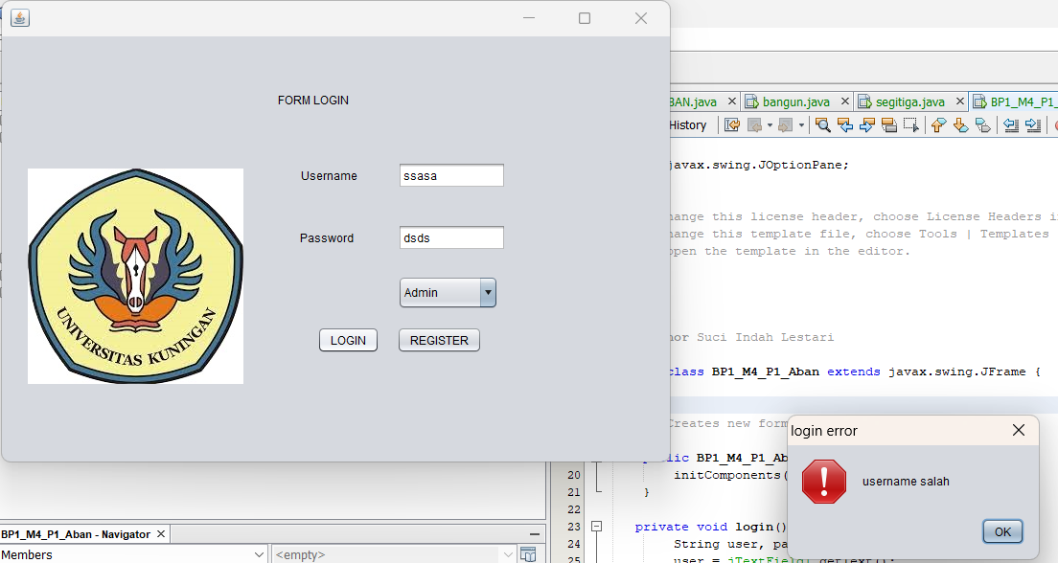

* Jika Password tidak diisi, maka akan menampilkan message “password harus diisi”

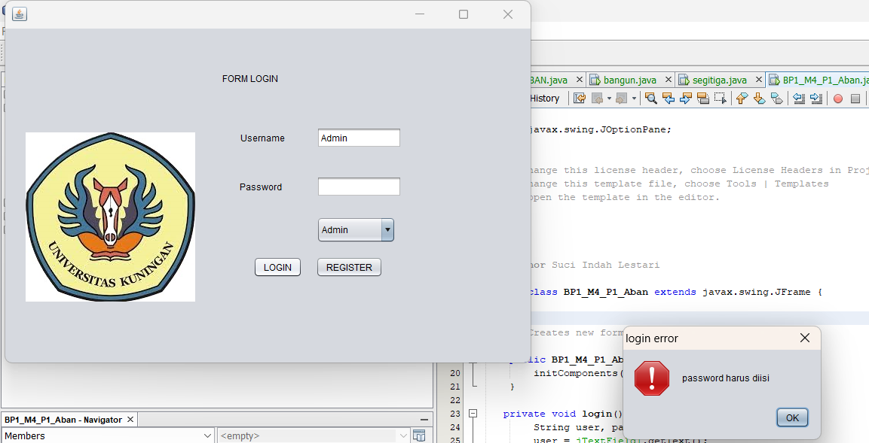

* Jika password salah, maka akan menampilkan message ”Password Salah”

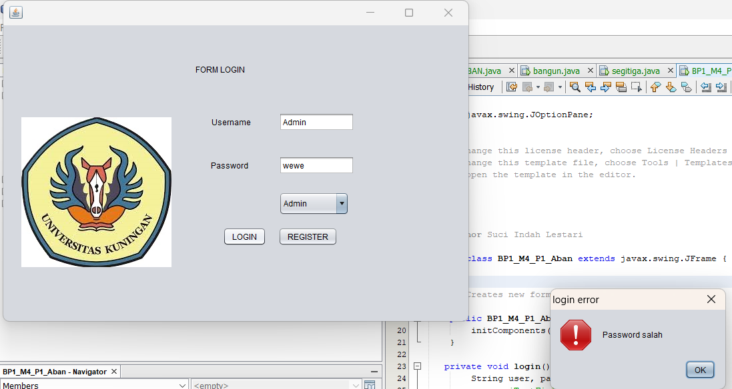

1. **Lengkapi form login pada praktikum dengan menambahkan level untuk login menggunakan JComboBox.Level yang di miliki adalah admin dan user ? disini saya sudah menambahkan nyaa.**
2. **Lengkapi kondisi register, sehingga memiliki kondisi**

**Jika button register pada form registrasi di klik, maka form registrasi Kembali kosong**

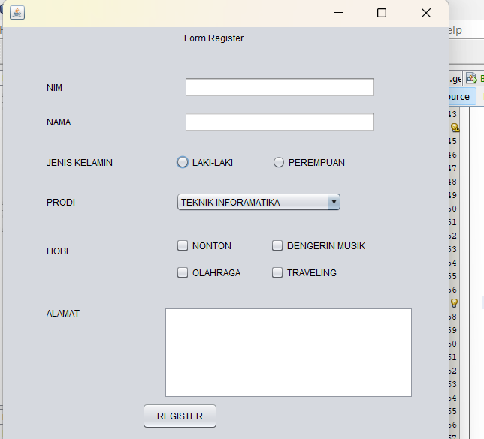

* Jika button register pada form registrasi di klik, maka akan tampil message “Registrasi Berhasil”

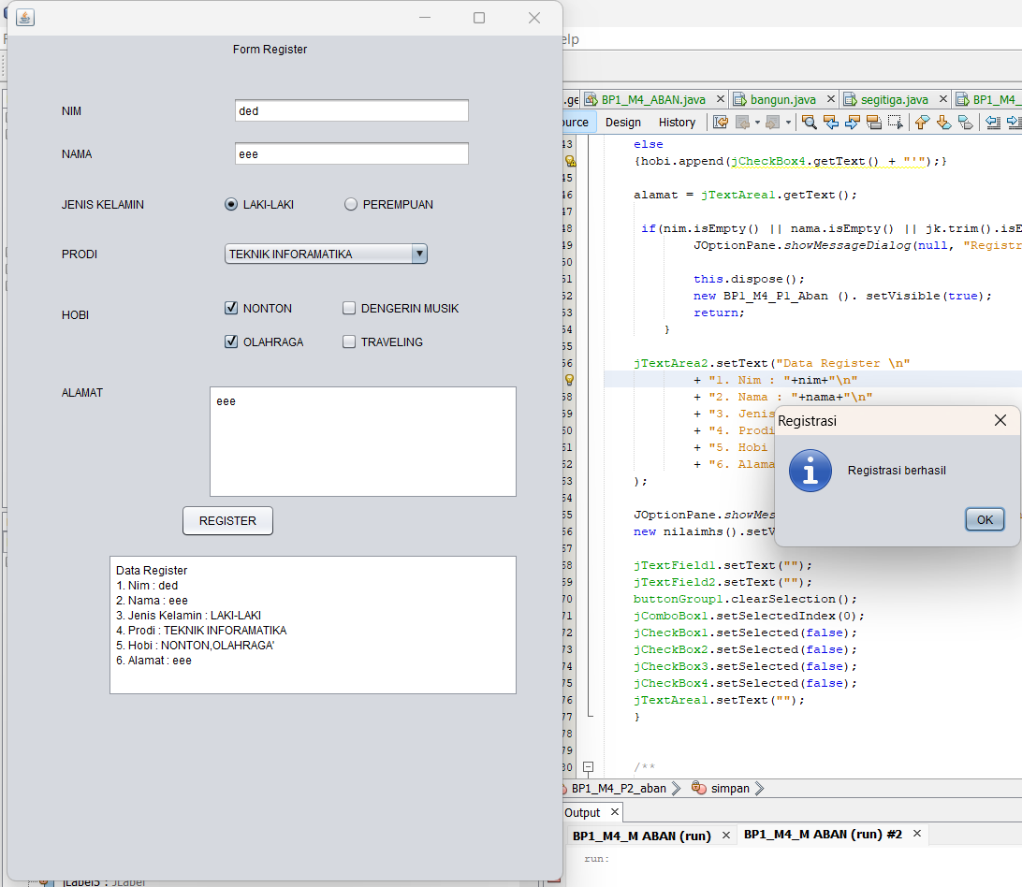

* Jika button register pada form register di klik, maka akan tampil message “register gagal, data harus lengkap” jika ada data yang tidak di isi

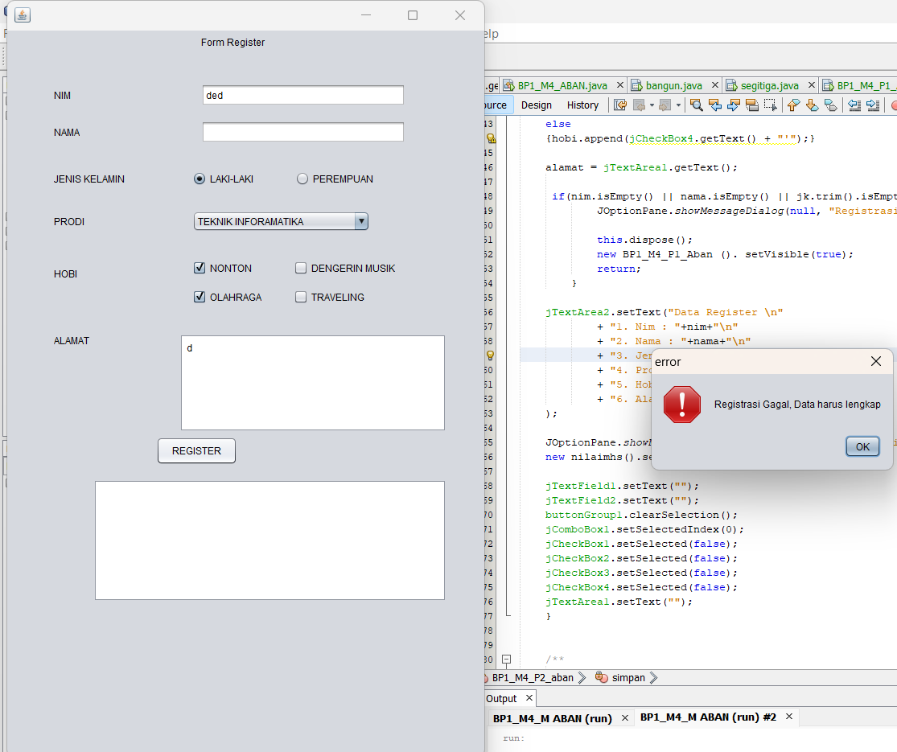

* Tambahkan tombol untuk keluar dari tampilan form registrasi

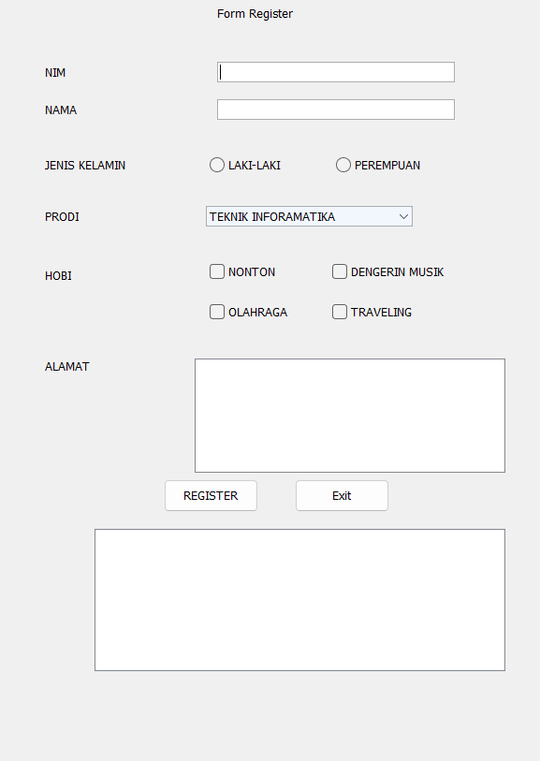

**Tugas**

1. **Lengkapi/ koneksi kan pada form login jika di klik maka akan tampil form register**
2. **Tambahkan Data yang harus diisi pada form register (Kelas, Angkatan, DPA, Semester)**

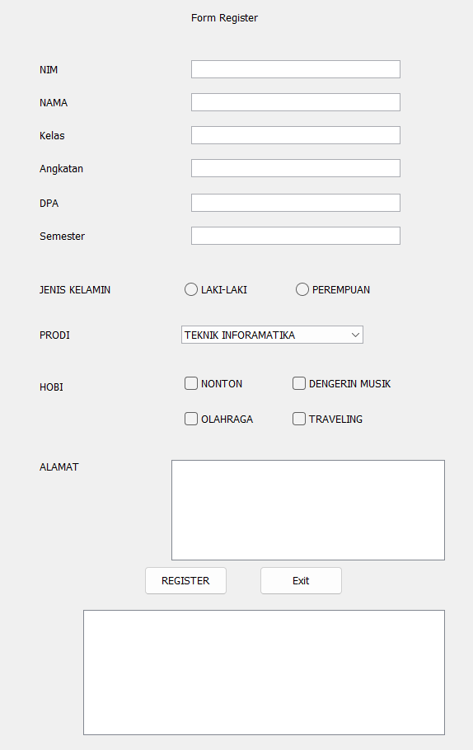

1. **Buat from data nilai mahasiswa**

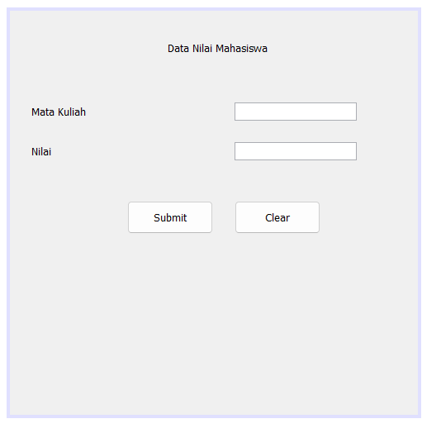

1. **Jika Register gagal, maka tampilan akan Kembali ke form login**
2. **Jika register berhasil, maka akan tampil form data nilai mahasiswa.**

**Code LOGIN**

import javax.swing.JOptionPane;

/*

* To change this license header, choose License Headers in Project Properties.

* To change this template file, choose Tools | Templates

* and open the template in the editor.

*/

/**

*

* @author Suci Indah Lestari

*/

public class BP1_M4_P1_Aban extends javax.swing.JFrame {

/**

* Creates new form BP1_M4_P1_Aban

*/

public BP1_M4_P1_Aban() {

initComponents();

}

private void login(){

String user, pass;

user = jTextField1.getText();

pass = jTextField2.getText();

if(user.equals("Admin")&&pass.equals("#Admin123")){

JOptionPane.showMessageDialog(null, "Login Sukses" +user, "Login ", JOptionPane.INFORMATION_MESSAGE);

}

else if(user.isEmpty())

{

JOptionPane.showMessageDialog(null, "username harus diisi", "login error", JOptionPane.ERROR_MESSAGE);

}

else if(!user.equals("Admin"))

{

JOptionPane.showMessageDialog(null, "username salah", "login error", JOptionPane.ERROR_MESSAGE);

}

else if(pass.isEmpty())

{

JOptionPane.showMessageDialog(null, "password harus diisi", "login error", JOptionPane.ERROR_MESSAGE);

}

else if(!pass.equals("#Admin123"))

{

JOptionPane.showMessageDialog(null, "Password salah", "login error", JOptionPane.ERROR_MESSAGE);

}

else{

JOptionPane.showMessageDialog(null,"Login Gagal","Login", JOptionPane.ERROR_MESSAGE);

}

}

/**

* This method is called from within the constructor to initialize the form.

* WARNING: Do NOT modify this code. The content of this method is always

* regenerated by the Form Editor.

*/

@SuppressWarnings("unchecked")

// <editor-fold defaultstate="collapsed" desc="Generated Code">

private void initComponents() {

jLabel1 = new javax.swing.JLabel();

jLabel2 = new javax.swing.JLabel();

jLabel3 = new javax.swing.JLabel();

jLabel4 = new javax.swing.JLabel();

jTextField1 = new javax.swing.JTextField();

jTextField2 = new javax.swing.JTextField();

jButton1 = new javax.swing.JButton();

jButton2 = new javax.swing.JButton();

jComboBox1 = new javax.swing.JComboBox<>();

setDefaultCloseOperation(javax.swing.WindowConstants.EXIT_ON_CLOSE);

jLabel1.setText("FORM LOGIN");

jLabel2.setIcon(new javax.swing.ImageIcon(getClass().getResource("/download.jpeg"))); // NOI18N

jLabel3.setText("Username");

jLabel4.setText("Password");

jTextField1.addActionListener(new java.awt.event.ActionListener() {

public void actionPerformed(java.awt.event.ActionEvent evt) {

jTextField1ActionPerformed(evt);

}

});

jTextField2.addActionListener(new java.awt.event.ActionListener() {

public void actionPerformed(java.awt.event.ActionEvent evt) {

jTextField2ActionPerformed(evt);

}

});

jButton1.setText("LOGIN");

jButton1.addMouseListener(new java.awt.event.MouseAdapter() {

public void mouseClicked(java.awt.event.MouseEvent evt) {

jButton1MouseClicked(evt);

}

});

jButton1.addActionListener(new java.awt.event.ActionListener() {

public void actionPerformed(java.awt.event.ActionEvent evt) {

jButton1ActionPerformed(evt);

}

});

jButton2.setText("REGISTER");

jButton2.addMouseListener(new java.awt.event.MouseAdapter() {

public void mouseClicked(java.awt.event.MouseEvent evt) {

jButton2MouseClicked(evt);

}

});

jButton2.addActionListener(new java.awt.event.ActionListener() {

public void actionPerformed(java.awt.event.ActionEvent evt) {

jButton2ActionPerformed(evt);

}

});

jComboBox1.setModel(new javax.swing.DefaultComboBoxModel<>(new String[] { "Admin", "User" }));

jComboBox1.addActionListener(new java.awt.event.ActionListener() {

public void actionPerformed(java.awt.event.ActionEvent evt) {

jComboBox1ActionPerformed(evt);

}

});

javax.swing.GroupLayout layout = new javax.swing.GroupLayout(getContentPane());

getContentPane().setLayout(layout);

layout.setHorizontalGroup(

layout.createParallelGroup(javax.swing.GroupLayout.Alignment.LEADING)

.addGroup(layout.createSequentialGroup()

.addGap(27, 27, 27)

.addGroup(layout.createParallelGroup(javax.swing.GroupLayout.Alignment.TRAILING)

.addGroup(layout.createSequentialGroup()

.addComponent(jLabel2, javax.swing.GroupLayout.PREFERRED_SIZE, 241, javax.swing.GroupLayout.PREFERRED_SIZE)

.addGroup(layout.createParallelGroup(javax.swing.GroupLayout.Alignment.LEADING)

.addGroup(layout.createSequentialGroup()

.addGap(43, 43, 43)

.addGroup(layout.createParallelGroup(javax.swing.GroupLayout.Alignment.TRAILING)

.addGroup(layout.createSequentialGroup()

.addComponent(jLabel3)

.addGap(42, 42, 42)

.addComponent(jTextField1, javax.swing.GroupLayout.PREFERRED_SIZE, 113, javax.swing.GroupLayout.PREFERRED_SIZE))

.addGroup(layout.createSequentialGroup()

.addComponent(jLabel4, javax.swing.GroupLayout.PREFERRED_SIZE, 84, javax.swing.GroupLayout.PREFERRED_SIZE)

.addGap(18, 18, 18)

.addGroup(layout.createParallelGroup(javax.swing.GroupLayout.Alignment.LEADING)

.addComponent(jComboBox1, javax.swing.GroupLayout.PREFERRED_SIZE, 105, javax.swing.GroupLayout.PREFERRED_SIZE)

.addComponent(jTextField2, javax.swing.GroupLayout.PREFERRED_SIZE, 113, javax.swing.GroupLayout.PREFERRED_SIZE)))))

.addGroup(layout.createSequentialGroup()

.addGap(61, 61, 61)

.addComponent(jButton1)

.addGap(18, 18, 18)

.addComponent(jButton2))))

.addGroup(layout.createSequentialGroup()

.addComponent(jLabel1, javax.swing.GroupLayout.PREFERRED_SIZE, 107, javax.swing.GroupLayout.PREFERRED_SIZE)

.addGap(131, 131, 131)))

.addContainerGap(171, Short.MAX_VALUE))

);

layout.setVerticalGroup(

layout.createParallelGroup(javax.swing.GroupLayout.Alignment.LEADING)

.addGroup(layout.createSequentialGroup()

.addGroup(layout.createParallelGroup(javax.swing.GroupLayout.Alignment.LEADING)

.addGroup(layout.createSequentialGroup()

.addGap(58, 58, 58)

.addComponent(jLabel1)

.addGap(57, 57, 57)

.addGroup(layout.createParallelGroup(javax.swing.GroupLayout.Alignment.BASELINE)

.addComponent(jTextField1, javax.swing.GroupLayout.PREFERRED_SIZE, javax.swing.GroupLayout.DEFAULT_SIZE, javax.swing.GroupLayout.PREFERRED_SIZE)

.addComponent(jLabel3))

.addGap(37, 37, 37)

.addGroup(layout.createParallelGroup(javax.swing.GroupLayout.Alignment.BASELINE)

.addComponent(jTextField2, javax.swing.GroupLayout.PREFERRED_SIZE, javax.swing.GroupLayout.DEFAULT_SIZE, javax.swing.GroupLayout.PREFERRED_SIZE)

.addComponent(jLabel4))

.addGap(26, 26, 26)

.addComponent(jComboBox1, javax.swing.GroupLayout.PREFERRED_SIZE, 35, javax.swing.GroupLayout.PREFERRED_SIZE)

.addGap(18, 18, 18)

.addGroup(layout.createParallelGroup(javax.swing.GroupLayout.Alignment.BASELINE)

.addComponent(jButton1)

.addComponent(jButton2)))

.addGroup(layout.createSequentialGroup()

.addGap(121, 121, 121)

.addComponent(jLabel2, javax.swing.GroupLayout.PREFERRED_SIZE, 258, javax.swing.GroupLayout.PREFERRED_SIZE)))

.addContainerGap(65, Short.MAX_VALUE))

);

pack();

}// </editor-fold>

private void jTextField1ActionPerformed(java.awt.event.ActionEvent evt) {

// TODO add your handling code here:

}

private void jButton2ActionPerformed(java.awt.event.ActionEvent evt) {

// TODO add your handling code here:

BP1_M4_P2_aban p2 = new BP1_M4_P2_aban();

p2.setVisible(true);

}

private void jButton1MouseClicked(java.awt.event.MouseEvent evt) {

// TODO add your handling code here;

}

private void jButton1ActionPerformed(java.awt.event.ActionEvent evt) {

// TODO add your handling code here:

login();

}

private void jTextField2ActionPerformed(java.awt.event.ActionEvent evt) {

// TODO add your handling code here:

}

private void jButton2MouseClicked(java.awt.event.MouseEvent evt) {

// TODO add your handling code here:

}

private void jComboBox1ActionPerformed(java.awt.event.ActionEvent evt) {

// TODO add your handling code here:

}

/**

* @param args the command line arguments

*/

public static void main(String args[]) {

/* Set the Nimbus look and feel */

//<editor-fold defaultstate="collapsed" desc=" Look and feel setting code (optional) ">

/* If Nimbus (introduced in Java SE 6) is not available, stay with the default look and feel.

* For details see http://download.oracle.com/javase/tutorial/uiswing/lookandfeel/plaf.html

*/

try {

for (javax.swing.UIManager.LookAndFeelInfo info : javax.swing.UIManager.getInstalledLookAndFeels()) {

if ("Nimbus".equals(info.getName())) {

javax.swing.UIManager.setLookAndFeel(info.getClassName());

break;

}

}

} catch (ClassNotFoundException ex) {

java.util.logging.Logger.getLogger(BP1_M4_P1_Aban.class.getName()).log(java.util.logging.Level.SEVERE, null, ex);

} catch (InstantiationException ex) {

java.util.logging.Logger.getLogger(BP1_M4_P1_Aban.class.getName()).log(java.util.logging.Level.SEVERE, null, ex);

} catch (IllegalAccessException ex) {

java.util.logging.Logger.getLogger(BP1_M4_P1_Aban.class.getName()).log(java.util.logging.Level.SEVERE, null, ex);

} catch (javax.swing.UnsupportedLookAndFeelException ex) {

java.util.logging.Logger.getLogger(BP1_M4_P1_Aban.class.getName()).log(java.util.logging.Level.SEVERE, null, ex);

}

//</editor-fold>

/* Create and display the form */

java.awt.EventQueue.invokeLater(new Runnable() {

public void run() {

new BP1_M4_P1_Aban().setVisible(true);

}

});

}

// Variables declaration - do not modify

private javax.swing.JButton jButton1;

private javax.swing.JButton jButton2;

private javax.swing.JComboBox<String> jComboBox1;

private javax.swing.JLabel jLabel1;

private javax.swing.JLabel jLabel2;

private javax.swing.JLabel jLabel3;

private javax.swing.JLabel jLabel4;

private javax.swing.JTextField jTextField1;

private javax.swing.JTextField jTextField2;

// End of variables declaration

}

**Code Register**

import javax.swing.JOptionPane;

/*

* To change this license header, choose License Headers in Project Properties.

* To change this template file, choose Tools | Templates

* and open the template in the editor.

*/

/**

*

* @author Suci Indah Lestari

*/

public class BP1_M4_P2_aban extends javax.swing.JFrame {

/**

* Creates new form BP1_M4_P2_aban

*/

public BP1_M4_P2_aban() {

initComponents();

}

private void simpan() {

String nim, nama, jk, prodi, alamat;

nim = jTextField1.getText(); nama = jTextField2.getText();

jk = " ";

if(buttonGroup1.isSelected(null)) {

jk = jRadioButton1.getText();

}else {

jk = jRadioButton2.getText();

}

prodi = (String) jComboBox1.getSelectedItem();

StringBuffer hobi = new StringBuffer();

if(jCheckBox1.isSelected())

{hobi.append(jCheckBox1.getText() + ",");}

if(jCheckBox2.isSelected())

{hobi.append(jCheckBox2.getText() + ",");}

if(jCheckBox3.isSelected())

{hobi.append(jCheckBox3.getText() + ",");}

else

{hobi.append(jCheckBox4.getText() + "'");}

alamat = jTextArea1.getText();

if(nim.isEmpty() || nama.isEmpty() || jk.trim().isEmpty() || prodi == null || alamat.isEmpty()) {

JOptionPane.showMessageDialog(null, "Registrasi Gagal, Data harus lengkap", "error", JOptionPane.ERROR_MESSAGE);

this.dispose();

new BP1_M4_P1_Aban (). setVisible(true);

return;

}

jTextArea2.setText("Data Register \n"

+ "1. Nim : "+nim+"\n"

+ "2. Nama : "+nama+"\n"

+ "3. Jenis Kelamin : "+jk+"\n"

+ "4. Prodi : "+prodi+"\n"

+ "5. Hobi : "+hobi+"\n"

+ "6. Alamat : "+alamat+"\n"

);

JOptionPane.showMessageDialog(null, "Registrasi berhasil", "Registrasi", JOptionPane.INFORMATION_MESSAGE);

new nilaimhs().setVisible(true);

jTextField1.setText("");

jTextField2.setText("");

buttonGroup1.clearSelection();

jComboBox1.setSelectedIndex(0);

jCheckBox1.setSelected(false);

jCheckBox2.setSelected(false);

jCheckBox3.setSelected(false);

jCheckBox4.setSelected(false);

jTextArea1.setText("");

}

/**

* This method is called from within the constructor to initialize the form.

* WARNING: Do NOT modify this code. The content of this method is always

* regenerated by the Form Editor.

*/

@SuppressWarnings("unchecked")

// <editor-fold defaultstate="collapsed" desc="Generated Code">

private void initComponents() {

buttonGroup1 = new javax.swing.ButtonGroup();

jScrollPane1 = new javax.swing.JScrollPane();

jTree1 = new javax.swing.JTree();

jLabel1 = new javax.swing.JLabel();

jLabel2 = new javax.swing.JLabel();

jLabel3 = new javax.swing.JLabel();

jLabel4 = new javax.swing.JLabel();

jTextField1 = new javax.swing.JTextField();

jRadioButton1 = new javax.swing.JRadioButton();

jRadioButton2 = new javax.swing.JRadioButton();

jLabel5 = new javax.swing.JLabel();

jCheckBox1 = new javax.swing.JCheckBox();

jCheckBox2 = new javax.swing.JCheckBox();

jCheckBox3 = new javax.swing.JCheckBox();

jCheckBox4 = new javax.swing.JCheckBox();

jLabel6 = new javax.swing.JLabel();

jButton1 = new javax.swing.JButton();

jScrollPane2 = new javax.swing.JScrollPane();

jTextArea1 = new javax.swing.JTextArea();

jScrollPane3 = new javax.swing.JScrollPane();

jTextArea2 = new javax.swing.JTextArea();

jComboBox1 = new javax.swing.JComboBox<>();

jLabel7 = new javax.swing.JLabel();

jTextField2 = new javax.swing.JTextField();

jButton2 = new javax.swing.JButton();

jLabel8 = new javax.swing.JLabel();

jTextField3 = new javax.swing.JTextField();

jTextField4 = new javax.swing.JTextField();

jLabel9 = new javax.swing.JLabel();

jTextField5 = new javax.swing.JTextField();

jLabel10 = new javax.swing.JLabel();

jLabel11 = new javax.swing.JLabel();

jTextField6 = new javax.swing.JTextField();

jScrollPane1.setViewportView(jTree1);

setDefaultCloseOperation(javax.swing.WindowConstants.EXIT_ON_CLOSE);

jLabel1.setText("Form Register");

jLabel2.setText("NIM");

jLabel3.setText("JENIS KELAMIN");

jLabel4.setText("PRODI");

jRadioButton1.setText("LAKI-LAKI");

jRadioButton2.setText("PEREMPUAN");

jLabel5.setText("HOBI");

jCheckBox1.setText("NONTON");

jCheckBox2.setText("DENGERIN MUSIK");

jCheckBox3.setText("TRAVELING");

jCheckBox3.addActionListener(new java.awt.event.ActionListener() {

public void actionPerformed(java.awt.event.ActionEvent evt) {

jCheckBox3ActionPerformed(evt);

}

});

jCheckBox4.setText("OLAHRAGA");

jLabel6.setText("ALAMAT");

jButton1.setText("REGISTER");

jButton1.addMouseListener(new java.awt.event.MouseAdapter() {

public void mouseClicked(java.awt.event.MouseEvent evt) {

jButton1MouseClicked(evt);

}

});

jButton1.addActionListener(new java.awt.event.ActionListener() {

public void actionPerformed(java.awt.event.ActionEvent evt) {

jButton1ActionPerformed(evt);

}

});

jTextArea1.setColumns(20);

jTextArea1.setRows(5);

jScrollPane2.setViewportView(jTextArea1);

jTextArea2.setColumns(20);

jTextArea2.setRows(5);

jScrollPane3.setViewportView(jTextArea2);

jComboBox1.setModel(new javax.swing.DefaultComboBoxModel<>(new String[] { "TEKNIK INFORAMATIKA", "SISTEM INFORMASI", "DESAIN KOMUNIKASI VISUAL", "MANAJEMEN INFORMATIKA", "TEKNIK SIPIL", " " }));

jLabel7.setText("NAMA");

jButton2.setText("Exit");

jButton2.addMouseListener(new java.awt.event.MouseAdapter() {

public void mouseClicked(java.awt.event.MouseEvent evt) {

jButton2MouseClicked(evt);

}

});

jButton2.addActionListener(new java.awt.event.ActionListener() {

public void actionPerformed(java.awt.event.ActionEvent evt) {

jButton2ActionPerformed(evt);

}

});

jLabel8.setText("Kelas");

jLabel9.setText("Angkatan");

jLabel10.setText("DPA");

jLabel11.setText("Semester");

javax.swing.GroupLayout layout = new javax.swing.GroupLayout(getContentPane());

getContentPane().setLayout(layout);

layout.setHorizontalGroup(

layout.createParallelGroup(javax.swing.GroupLayout.Alignment.LEADING)

.addGroup(layout.createSequentialGroup()

.addGap(58, 58, 58)

.addGroup(layout.createParallelGroup(javax.swing.GroupLayout.Alignment.LEADING)

.addGroup(layout.createSequentialGroup()

.addGroup(layout.createParallelGroup(javax.swing.GroupLayout.Alignment.LEADING)

.addComponent(jLabel8)

.addGroup(layout.createParallelGroup(javax.swing.GroupLayout.Alignment.TRAILING)

.addComponent(jScrollPane3, javax.swing.GroupLayout.PREFERRED_SIZE, 439, javax.swing.GroupLayout.PREFERRED_SIZE)

.addGroup(layout.createParallelGroup(javax.swing.GroupLayout.Alignment.LEADING)

.addGroup(layout.createSequentialGroup()

.addComponent(jLabel6)

.addGap(112, 112, 112)

.addComponent(jScrollPane2, javax.swing.GroupLayout.PREFERRED_SIZE, 332, javax.swing.GroupLayout.PREFERRED_SIZE))

.addComponent(jLabel5)

.addGroup(layout.createSequentialGroup()

.addGroup(layout.createParallelGroup(javax.swing.GroupLayout.Alignment.LEADING)

.addComponent(jLabel3, javax.swing.GroupLayout.PREFERRED_SIZE, 89, javax.swing.GroupLayout.PREFERRED_SIZE)

.addComponent(jLabel4)

.addComponent(jLabel10)

.addComponent(jLabel11))

.addGap(83, 83, 83)

.addGroup(layout.createParallelGroup(javax.swing.GroupLayout.Alignment.LEADING)

.addGroup(layout.createSequentialGroup()

.addComponent(jRadioButton1)

.addGap(52, 52, 52)

.addComponent(jRadioButton2))

.addComponent(jComboBox1, javax.swing.GroupLayout.PREFERRED_SIZE, 221, javax.swing.GroupLayout.PREFERRED_SIZE)

.addGroup(layout.createSequentialGroup()

.addGroup(layout.createParallelGroup(javax.swing.GroupLayout.Alignment.LEADING)

.addComponent(jCheckBox1)

.addComponent(jCheckBox4))

.addGap(40, 40, 40)

.addGroup(layout.createParallelGroup(javax.swing.GroupLayout.Alignment.LEADING)

.addComponent(jCheckBox3)

.addComponent(jCheckBox2)))))))

.addGroup(layout.createSequentialGroup()

.addGap(127, 127, 127)

.addComponent(jButton1, javax.swing.GroupLayout.PREFERRED_SIZE, 101, javax.swing.GroupLayout.PREFERRED_SIZE)

.addGap(39, 39, 39)

.addComponent(jButton2, javax.swing.GroupLayout.PREFERRED_SIZE, 101, javax.swing.GroupLayout.PREFERRED_SIZE))

.addComponent(jLabel7))

.addGap(0, 0, Short.MAX_VALUE))

.addGroup(layout.createSequentialGroup()

.addGroup(layout.createParallelGroup(javax.swing.GroupLayout.Alignment.TRAILING)

.addComponent(jTextField5, javax.swing.GroupLayout.PREFERRED_SIZE, 254, javax.swing.GroupLayout.PREFERRED_SIZE)

.addGroup(layout.createParallelGroup(javax.swing.GroupLayout.Alignment.TRAILING, false)

.addComponent(jTextField2, javax.swing.GroupLayout.PREFERRED_SIZE, 254, javax.swing.GroupLayout.PREFERRED_SIZE)

.addGroup(layout.createSequentialGroup()

.addComponent(jLabel2)

.addGap(162, 162, 162)

.addGroup(layout.createParallelGroup(javax.swing.GroupLayout.Alignment.LEADING)

.addComponent(jLabel1, javax.swing.GroupLayout.PREFERRED_SIZE, 132, javax.swing.GroupLayout.PREFERRED_SIZE)

.addComponent(jTextField1, javax.swing.GroupLayout.PREFERRED_SIZE, 254, javax.swing.GroupLayout.PREFERRED_SIZE)))

.addComponent(jTextField3, javax.swing.GroupLayout.PREFERRED_SIZE, 254, javax.swing.GroupLayout.PREFERRED_SIZE)

.addGroup(layout.createSequentialGroup()

.addComponent(jLabel9)

.addPreferredGap(javax.swing.LayoutStyle.ComponentPlacement.RELATED, javax.swing.GroupLayout.DEFAULT_SIZE, Short.MAX_VALUE)

.addComponent(jTextField4, javax.swing.GroupLayout.PREFERRED_SIZE, 254, javax.swing.GroupLayout.PREFERRED_SIZE)))

.addComponent(jTextField6, javax.swing.GroupLayout.PREFERRED_SIZE, 254, javax.swing.GroupLayout.PREFERRED_SIZE))

.addContainerGap(98, Short.MAX_VALUE))))

);

layout.setVerticalGroup(

layout.createParallelGroup(javax.swing.GroupLayout.Alignment.LEADING)

.addGroup(layout.createSequentialGroup()

.addContainerGap()

.addComponent(jLabel1)

.addGap(44, 44, 44)

.addGroup(layout.createParallelGroup(javax.swing.GroupLayout.Alignment.BASELINE)

.addComponent(jLabel2)

.addComponent(jTextField1, javax.swing.GroupLayout.PREFERRED_SIZE, javax.swing.GroupLayout.DEFAULT_SIZE, javax.swing.GroupLayout.PREFERRED_SIZE))

.addGap(18, 18, 18)

.addGroup(layout.createParallelGroup(javax.swing.GroupLayout.Alignment.BASELINE)

.addComponent(jLabel7)

.addComponent(jTextField2, javax.swing.GroupLayout.PREFERRED_SIZE, javax.swing.GroupLayout.DEFAULT_SIZE, javax.swing.GroupLayout.PREFERRED_SIZE))

.addGap(18, 18, 18)

.addGroup(layout.createParallelGroup(javax.swing.GroupLayout.Alignment.BASELINE)

.addComponent(jLabel8)

.addComponent(jTextField3, javax.swing.GroupLayout.PREFERRED_SIZE, javax.swing.GroupLayout.DEFAULT_SIZE, javax.swing.GroupLayout.PREFERRED_SIZE))

.addGap(18, 18, 18)

.addGroup(layout.createParallelGroup(javax.swing.GroupLayout.Alignment.BASELINE)

.addComponent(jTextField4, javax.swing.GroupLayout.PREFERRED_SIZE, javax.swing.GroupLayout.DEFAULT_SIZE, javax.swing.GroupLayout.PREFERRED_SIZE)

.addComponent(jLabel9))

.addGap(20, 20, 20)

.addGroup(layout.createParallelGroup(javax.swing.GroupLayout.Alignment.BASELINE)

.addComponent(jTextField5, javax.swing.GroupLayout.PREFERRED_SIZE, javax.swing.GroupLayout.DEFAULT_SIZE, javax.swing.GroupLayout.PREFERRED_SIZE)

.addComponent(jLabel10))

.addGap(18, 18, 18)

.addGroup(layout.createParallelGroup(javax.swing.GroupLayout.Alignment.BASELINE)

.addComponent(jLabel11)

.addComponent(jTextField6, javax.swing.GroupLayout.PREFERRED_SIZE, javax.swing.GroupLayout.DEFAULT_SIZE, javax.swing.GroupLayout.PREFERRED_SIZE))

.addGap(42, 42, 42)

.addGroup(layout.createParallelGroup(javax.swing.GroupLayout.Alignment.BASELINE)

.addComponent(jLabel3)

.addComponent(jRadioButton1)

.addComponent(jRadioButton2))

.addGap(31, 31, 31)

.addGroup(layout.createParallelGroup(javax.swing.GroupLayout.Alignment.BASELINE)

.addComponent(jComboBox1, javax.swing.GroupLayout.PREFERRED_SIZE, javax.swing.GroupLayout.DEFAULT_SIZE, javax.swing.GroupLayout.PREFERRED_SIZE)

.addComponent(jLabel4))

.addGroup(layout.createParallelGroup(javax.swing.GroupLayout.Alignment.LEADING)

.addGroup(layout.createSequentialGroup()

.addGap(44, 44, 44)

.addComponent(jLabel5))

.addGroup(layout.createSequentialGroup()

.addGap(36, 36, 36)

.addGroup(layout.createParallelGroup(javax.swing.GroupLayout.Alignment.BASELINE)

.addComponent(jCheckBox1)

.addComponent(jCheckBox2))

.addGap(18, 18, 18)

.addGroup(layout.createParallelGroup(javax.swing.GroupLayout.Alignment.BASELINE)

.addComponent(jCheckBox4)

.addComponent(jCheckBox3))))

.addGap(37, 37, 37)

.addGroup(layout.createParallelGroup(javax.swing.GroupLayout.Alignment.LEADING)

.addComponent(jLabel6)

.addComponent(jScrollPane2, javax.swing.GroupLayout.PREFERRED_SIZE, 122, javax.swing.GroupLayout.PREFERRED_SIZE))

.addPreferredGap(javax.swing.LayoutStyle.ComponentPlacement.RELATED, javax.swing.GroupLayout.DEFAULT_SIZE, Short.MAX_VALUE)

.addGroup(layout.createParallelGroup(javax.swing.GroupLayout.Alignment.BASELINE)

.addComponent(jButton1, javax.swing.GroupLayout.PREFERRED_SIZE, 35, javax.swing.GroupLayout.PREFERRED_SIZE)

.addComponent(jButton2, javax.swing.GroupLayout.PREFERRED_SIZE, 35, javax.swing.GroupLayout.PREFERRED_SIZE))

.addGap(18, 18, 18)

.addComponent(jScrollPane3, javax.swing.GroupLayout.PREFERRED_SIZE, 152, javax.swing.GroupLayout.PREFERRED_SIZE)

.addGap(24, 24, 24))

);

pack();

}// </editor-fold>

private void jCheckBox3ActionPerformed(java.awt.event.ActionEvent evt) {

// TODO add your handling code here:

}

private void jButton1MouseClicked(java.awt.event.MouseEvent evt) {

// TODO add your handling code here:

}

private void jButton1ActionPerformed(java.awt.event.ActionEvent evt) {

// TODO add your handling code here:

simpan();

}

private void jButton2ActionPerformed(java.awt.event.ActionEvent evt) {

// TODO add your handling code here:

}

private void jButton2MouseClicked(java.awt.event.MouseEvent evt) {

// TODO add your handling code here:

System.exit(0);

}

/**

* @param args the command line arguments

*/

public static void main(String args[]) {

/* Set the Nimbus look and feel */

//<editor-fold defaultstate="collapsed" desc=" Look and feel setting code (optional) ">

/* If Nimbus (introduced in Java SE 6) is not available, stay with the default look and feel.

* For details see http://download.oracle.com/javase/tutorial/uiswing/lookandfeel/plaf.html

*/

try {

for (javax.swing.UIManager.LookAndFeelInfo info : javax.swing.UIManager.getInstalledLookAndFeels()) {

if ("Nimbus".equals(info.getName())) {

javax.swing.UIManager.setLookAndFeel(info.getClassName());

break;

}

}

} catch (ClassNotFoundException ex) {

java.util.logging.Logger.getLogger(BP1_M4_P2_aban.class.getName()).log(java.util.logging.Level.SEVERE, null, ex);

} catch (InstantiationException ex) {

java.util.logging.Logger.getLogger(BP1_M4_P2_aban.class.getName()).log(java.util.logging.Level.SEVERE, null, ex);

} catch (IllegalAccessException ex) {

java.util.logging.Logger.getLogger(BP1_M4_P2_aban.class.getName()).log(java.util.logging.Level.SEVERE, null, ex);

} catch (javax.swing.UnsupportedLookAndFeelException ex) {

java.util.logging.Logger.getLogger(BP1_M4_P2_aban.class.getName()).log(java.util.logging.Level.SEVERE, null, ex);

}

//</editor-fold>

/* Create and display the form */

java.awt.EventQueue.invokeLater(new Runnable() {

public void run() {

new BP1_M4_P2_aban().setVisible(true);

}

});

}

// Variables declaration - do not modify

private javax.swing.ButtonGroup buttonGroup1;

private javax.swing.JButton jButton1;

private javax.swing.JButton jButton2;

private javax.swing.JCheckBox jCheckBox1;

private javax.swing.JCheckBox jCheckBox2;

private javax.swing.JCheckBox jCheckBox3;

private javax.swing.JCheckBox jCheckBox4;

private javax.swing.JComboBox<String> jComboBox1;

private javax.swing.JLabel jLabel1;

private javax.swing.JLabel jLabel10;

private javax.swing.JLabel jLabel11;

private javax.swing.JLabel jLabel2;

private javax.swing.JLabel jLabel3;

private javax.swing.JLabel jLabel4;

private javax.swing.JLabel jLabel5;

private javax.swing.JLabel jLabel6;

private javax.swing.JLabel jLabel7;

private javax.swing.JLabel jLabel8;

private javax.swing.JLabel jLabel9;

private javax.swing.JRadioButton jRadioButton1;

private javax.swing.JRadioButton jRadioButton2;

private javax.swing.JScrollPane jScrollPane1;

private javax.swing.JScrollPane jScrollPane2;

private javax.swing.JScrollPane jScrollPane3;

private javax.swing.JTextArea jTextArea1;

private javax.swing.JTextArea jTextArea2;

private javax.swing.JTextField jTextField1;

private javax.swing.JTextField jTextField2;

private javax.swing.JTextField jTextField3;

private javax.swing.JTextField jTextField4;

private javax.swing.JTextField jTextField5;

private javax.swing.JTextField jTextField6;

private javax.swing.JTree jTree1;

// End of variables declaration

}